**Embedded systems learning journal**

**Assembly language**

**Joseph Batchelor**

**Task 1: Traffic Light Simulation using assembly language**

This task’s objective is to simulate a traffic light environment with the use of assembly. In order for this to be achieved there are some requirements that need to be met.

Requirements:

1. Write a function to control each of the traffic lights in assembly
2. Use the serial port to simulate the pedestrian pressing the button
3. Both sets of traffic lights should be red in order for the pedestrians to cross safely.
4. The pedestrian green LED should flash as a warning that the main lights are about to start up
5. The main lights should sequence to and from pedestrian crossing mode in a safe and tidy sequence.
6. The state of the lights should be written to the serial port

**Task 1:** Obtain an Arduino Uno or Mega Board and connect it to the PC.

The first step of task 1 is to set up my working environment. This meant I had to setup my Arduino and obtain the necessary components for me to achieve this task. Below is a list of the components need throughout this assessment.

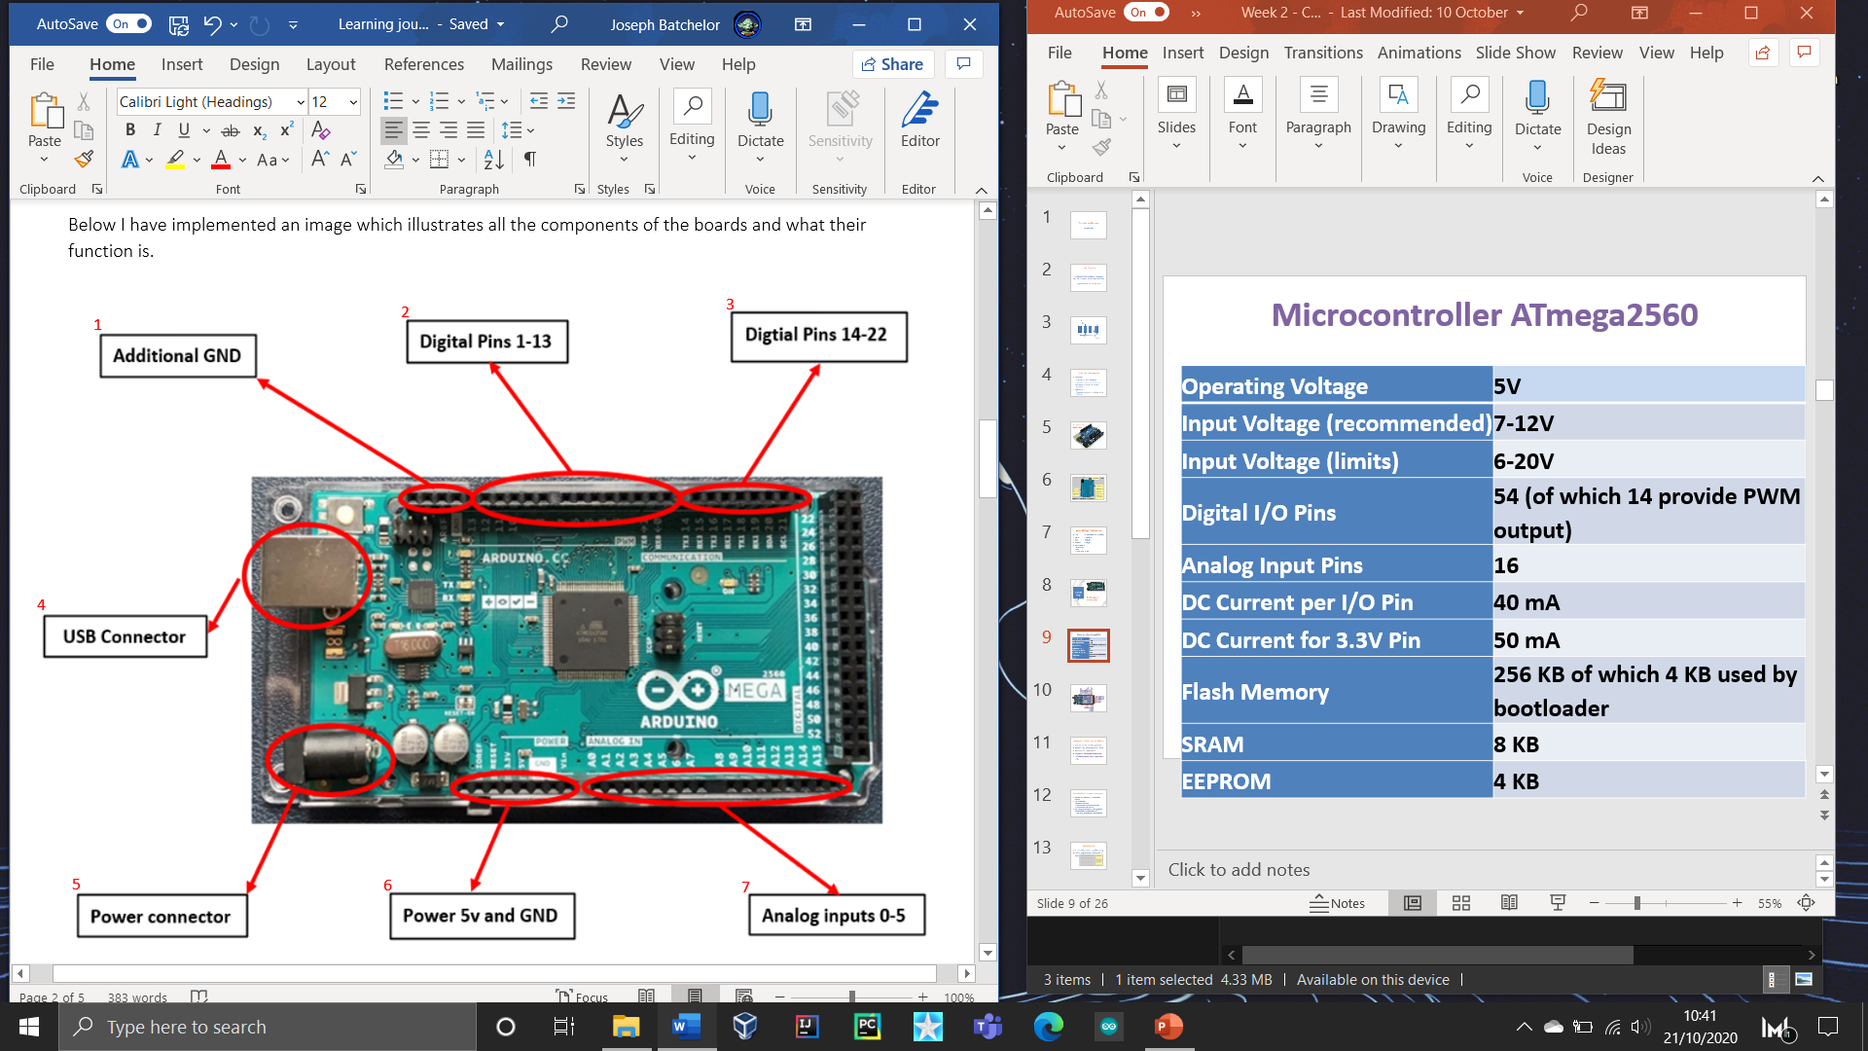Components:

* **1x** Arduino board Mega 2560
* **8x** LEDs of different colours .
* **1x** USB type A to type B.
* **17x** Pin connectors
* **1x** Breadboard

**Task 2:** From the computing programmes select Arduino program.

This assessment requires us to utilise the use of inline assembly. More specifically the Arduino environment uses extended avr gcc assembly which has an integrated assembler that takes C code and converts it into binary. With the task we must create code which uses a mixture of C and extended inline assembly.

New board manager

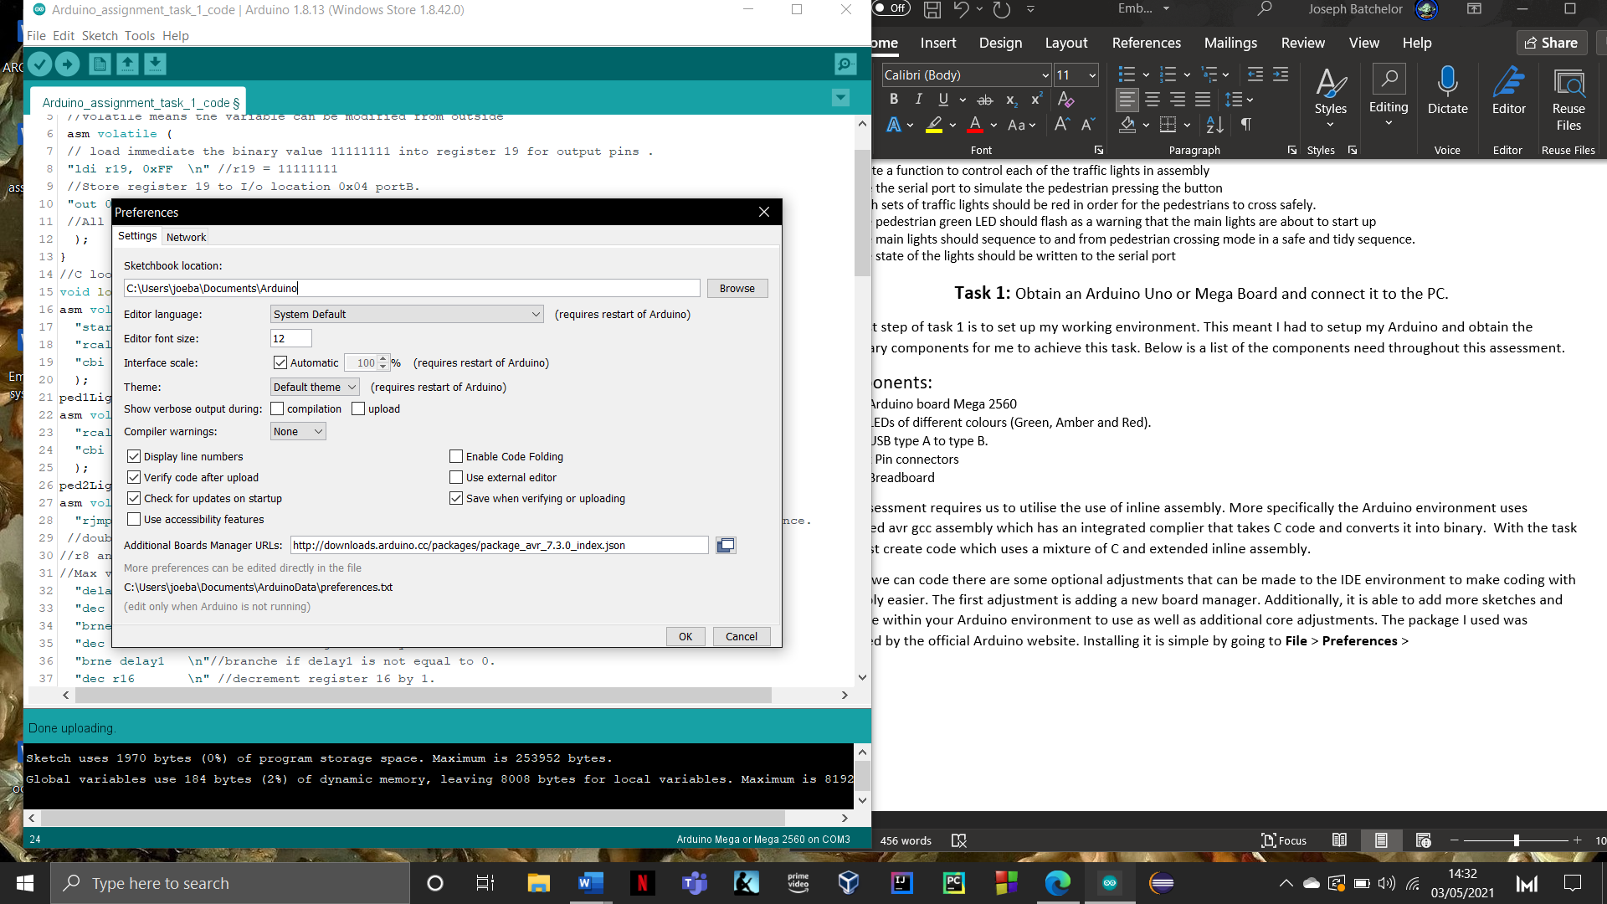Before we can code there are some optional adjustments that can be made to the IDE environment to make coding with assembly easier. The first adjustment is adding a new board manager. Additionally, it is able to add more sketches and examples within your Arduino environment to use as well as additional core adjustments. The package I used was provided by the official Arduino website. Installing it is simple by going to **File** > **Preferences.** You will be presented with the Arduino IDE settings, from there head to the **Additional Boards Manager URLs:** and paste in the URL of the package you want.

The package I have chosen <http://downloads.arduino.cc/packages/package_avr_7.3.0_index.json> offers a hand full of adjustments such as manuals which makes learning inline assembly easier.

Library manager

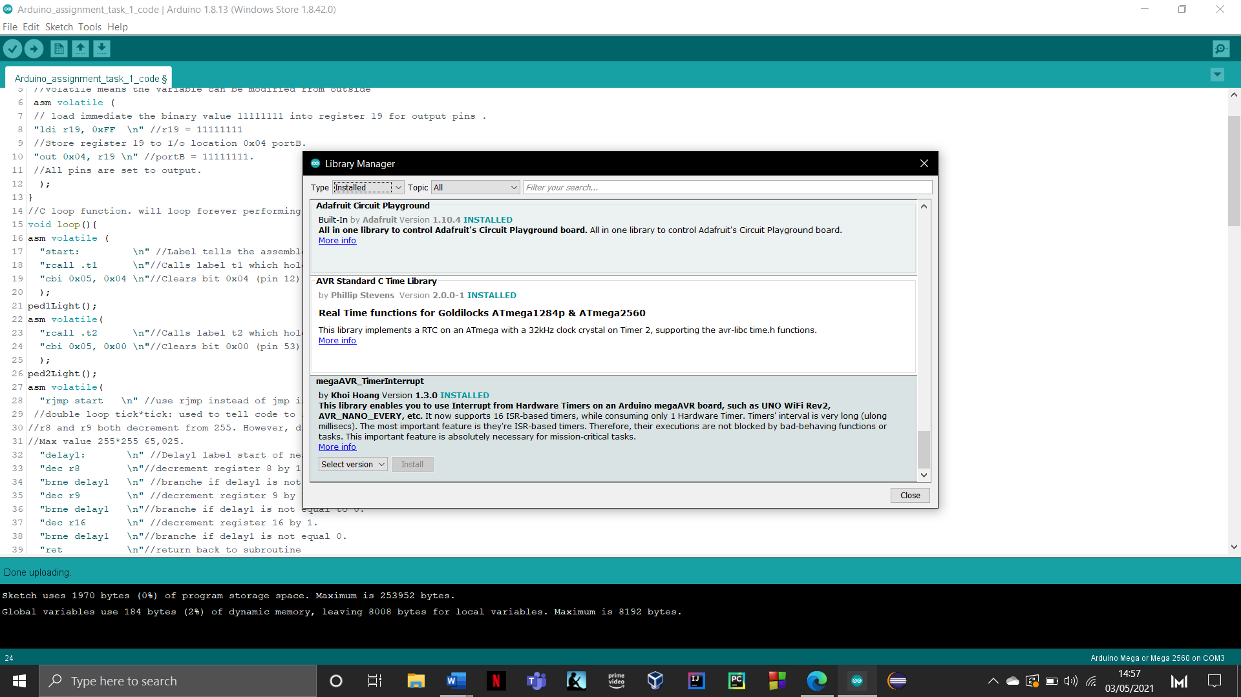Library manager is an integrated Arduino feature which introduces the ability add different libraries. Adding additional libraries extends the functionality of your Arduino. Libraries are a collection of code that makes it easy for you introduces different / additional functionality. By using forums, I look for the most used and recommend ones. Once you have found some it is a simple process to add them to your IDE. Go to **Tools** > **Manage libraries** from their search for the libraries you wish to add. Below are photos of the libraries added.



**Task 3:** Develop and draw a flowchart of a simple four-phase traffic light.

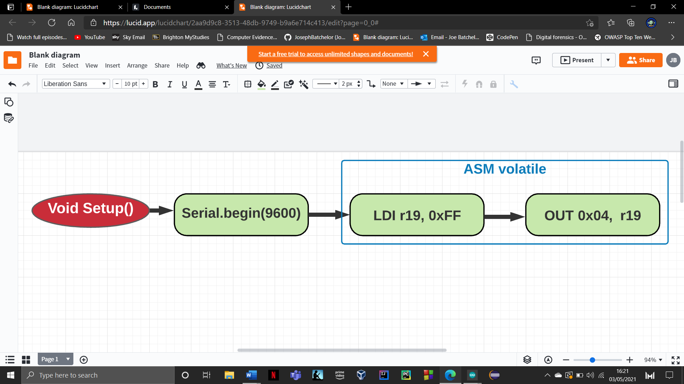The first development task is to create a single four phase traffic light system within the Arduino environment with the use of assembly. This traffic system must include three LEDs of various colours (Red, Amber and Green). We must also create a flow chart of the design. Below are the separate areas that make up the task individually broken down and discussed.

Void setup()is designed to run all the necessary components once before each execution. This case we are setting up the serial monitor for later communication. I have also introduced some assembly which is displayed in the blue container. The blue container represents the code **ASM Volatile** this used to specify to the assembler embedded assembly instructions within c code. **Volatile** indicates that a value may change between different accesses i.e when passed through embed assembly.

This will assign register 19 with the hex value 0xFF (11111111). This is done using **LDI** mnemonic which means **Load immediate**. This mnemonic will load an 8-bit constant directly to register 16 to 31. Register 19 is then stored into I/0 location 0x04 which is PortB. This is done using the mnemonic **OUT** which stores data from a register file to an I/O space. This essentially tells the Arduino board that pins 53, 52, 51, 50, 13, 12, 11 and 10 have been set to output which means that they can be illuminated for the task.

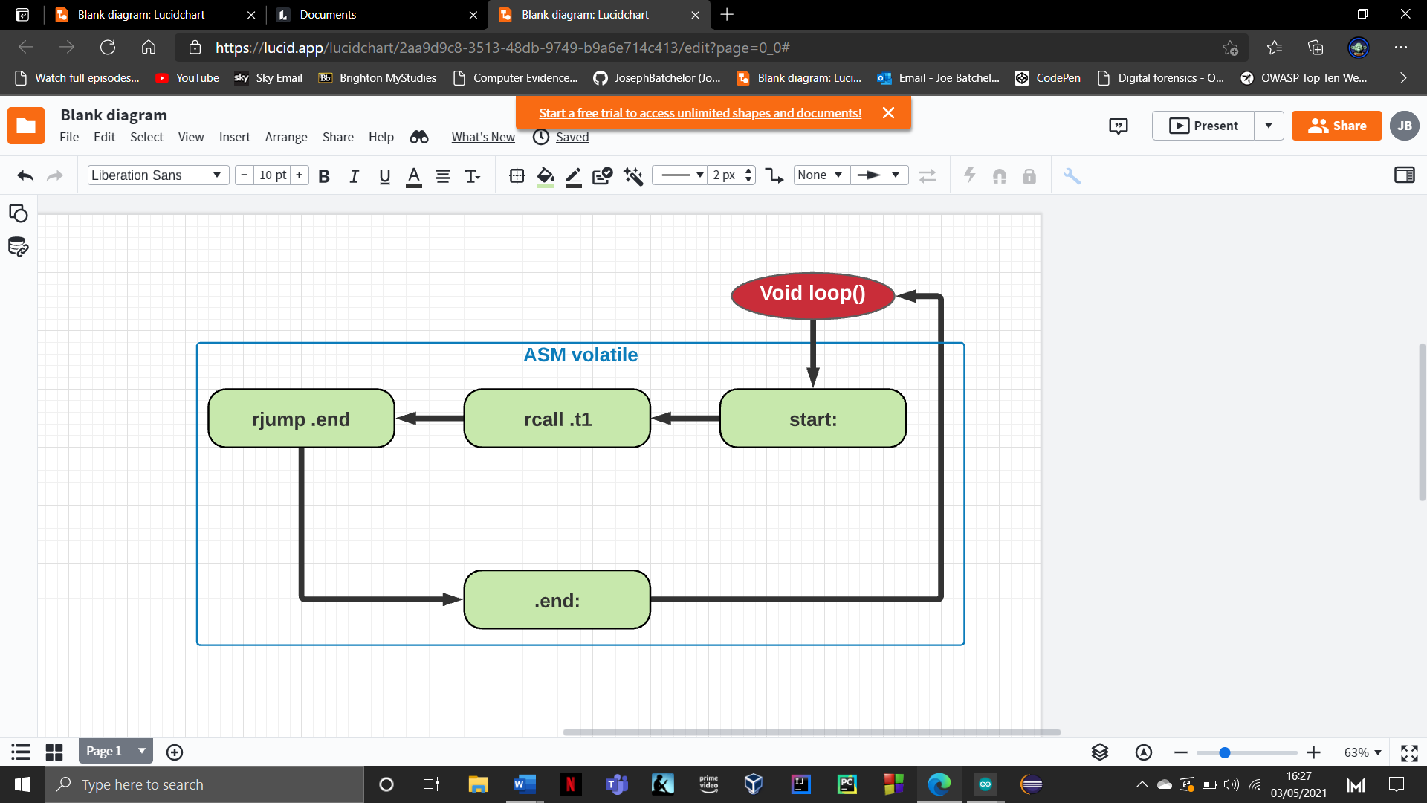

This next diagram displays the function loop() which is simple and straight forward. Loop will constantly run the same embedded assembly instructions. The first line the assembler reads is the **start:** label. Labels are a similar to functions as they allow us to organise code and segregate it in this case the **Start** label tells the assembler this is where the assembly starts. The next line is **rcall .t1** this tells the assembler to call label .t1 to execute. **Rcall**  means **relative call to subroutine.**

The last line **rjmp .end** means relative jump to label end. Instead of calling it and executing it. It will instead jump to the location and carry-on execution from there. When done this scenario will end this function and loop back to the top to start execution again. **Rjmp** mnemonic is the ability to jump to addresses.

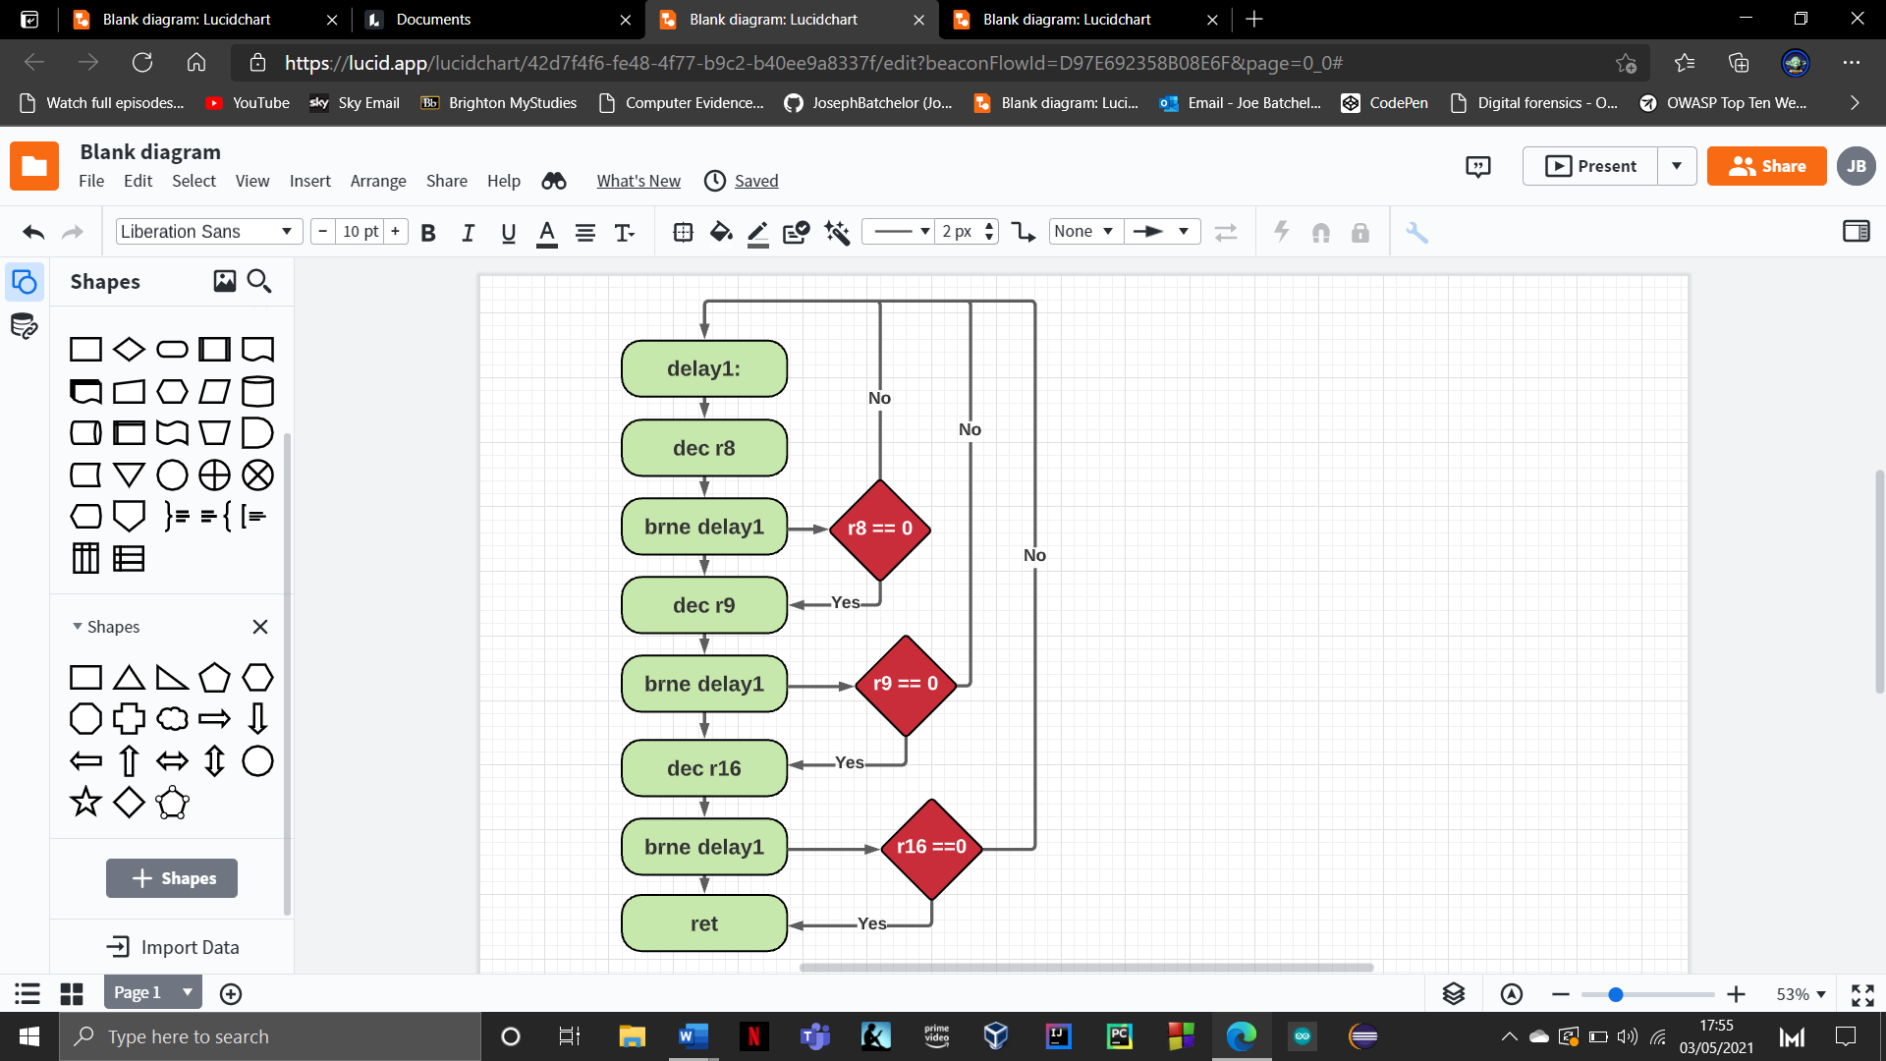

Label **delay1** and **delay2** are used to create a delay between LEDS. This means that execution of code is stopped for a certain duration.

Unfortunately, unlike the Arduino environment assembly does not incorporate built in functions such as delay(). This means you have to create a delay loop which uses decrementing registers to stop the execution of code.

The way this works is different registers which automatically when used has a value of 255. Whenever the **delay1** is called it will perform a **double tick delay** which uses two registers. Whereas **delay2** uses three registers which is a **triple tick delay. Dec** mnemonic subtracts 1 from the contents within a register. After a register has be decremented it will use the mnemonic **BRNE** which means branch if not equal.

This is a conditional relative branch that tests the zero flag. In this case if a register does not equal 0 it will branch back to the top of the delay label and repeat decrementing a register until it hits 0 which will then branch to the next register and so on. Changing the duration of the delay is done by storing different values in register 16. To calculate the right time in seconds for a double tick delay you need to use the calculation **(r8 x r9 x r16)/1,000,000** and for a triple tick is **(r8 x r9 x r10 x r16)/1,000,000**. An example for delay1 (255*255*100)/1,000,000 = 6.5 seconds.

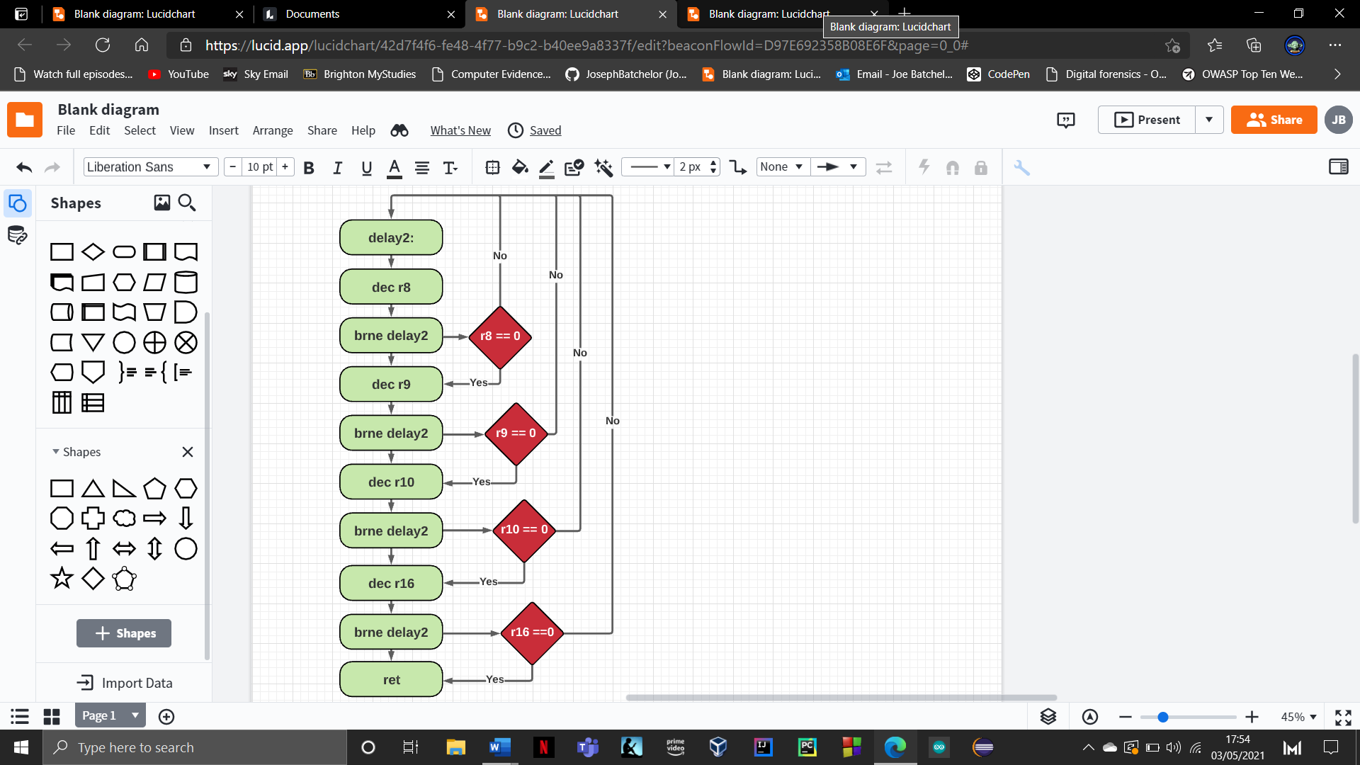

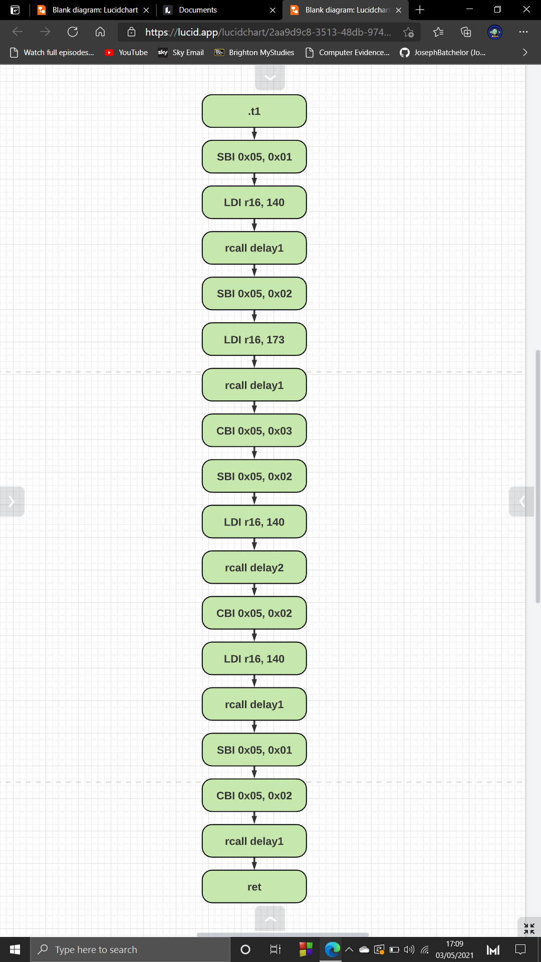

This is a function called .t1 which is responsible for holding my four-phase traffic light set. This function is called in function loop seen above. It starts of will a **label** which is used as an identifier.

Throughout this function I use various mnemonics which contribute to the illumination of different LEDs in a sequence. The first mnemonic is **SBI** which sets a specified bit in an I/O register between 0 – 31.

This line when broken simply means that I/O register **0x05** set **0x01** on. **0x05** is the address offset which is essentially the location of PORTB. This allows for pin to bit assignment on **PORTB**. The **0x01** is the bit value which in this case of a mega board is **pin 52**. This means that **SBI 0X05, 0X01** will change **0x01** (pin 52) found in address **0x05** (PORTB) from a 0 to a 1, which is equivalent to turning on that pins LED.

The next line Loads register 16 with the value 140. This is used in the delay1 function discussed earlier. By changing the value in register 16 this will allow me to have different delays. By loading a different value and then calling delay1 will stop execution.

The next mnemonic that is used is **CBI** which essentially acts as the opposite of **SBI. CBI** clears a specified bit in an I/O address register, in detail it converts the bit from a 1 to a 0. As a whole **CBI 0X05, 0X03** will change **0x03** (pin 50) found in address **0x05** (PORTB) from a 1 to a 0, which is equivalent to turning off that pins LED.

Using the mnemonics **SBI** and **CBI** allows me to turn LED’s on and off. This allows me to correctly demonstrate the four-phase light sequence.

Additionally, incorporating either **delay1** or **delay2** will allow me to stop execution of instructions briefly. The reason I use two delay timers is because delay can only perform at a max 16 seconds if I set register 16 to 255. However, if I introduce a triple tick delay this mean I accomplish a 10 second delay if I set register 16 to value 3. This offers me a greater delay if needed.

After the instruction set has finished executing the last mnemonic is **ret** which means return to subroutine. **Ret** will return where it was called. This will obtain the return address of the subroutine from the **STACK.** The address is saved with a stack pointer.

As a whole function .t1 one will perform the four-phase light sequence and then return to the .t1 call found in function loop and carry on with execution.

Below are some images which display the implemented code working correctly.

Below is the completed version of the flow chart which links everything tighter into one.

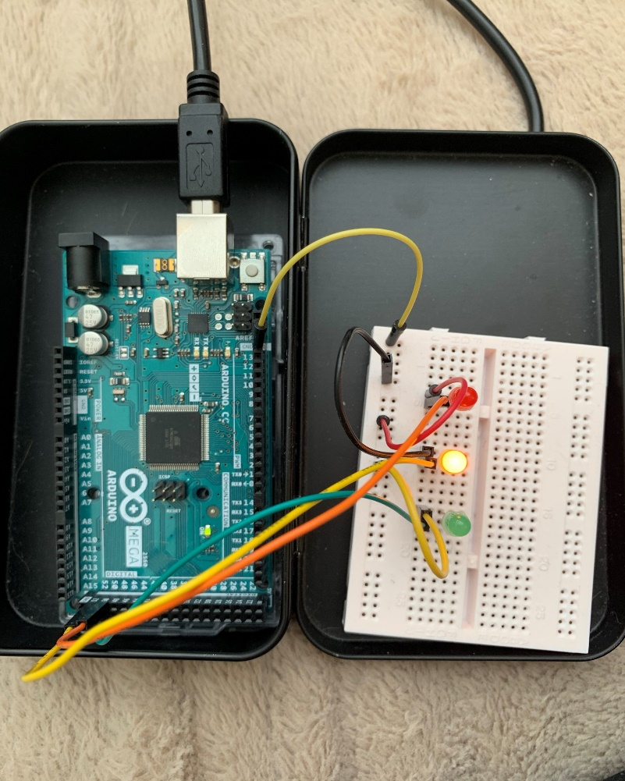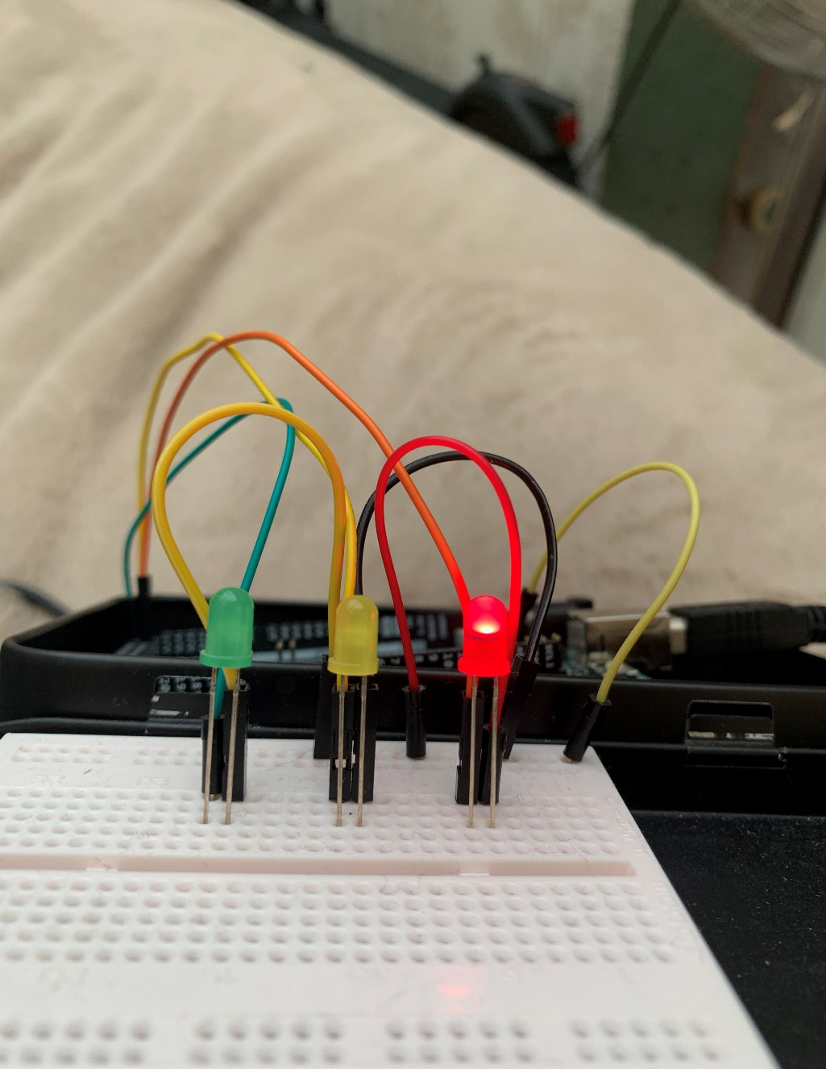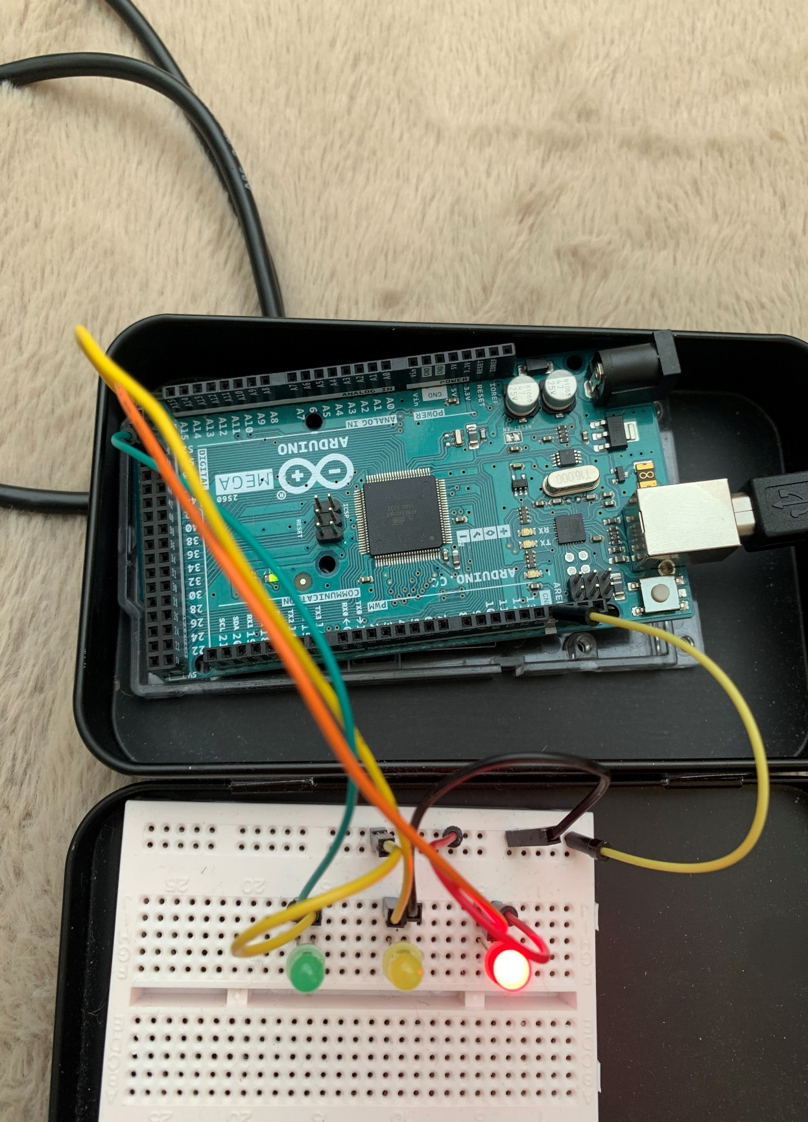

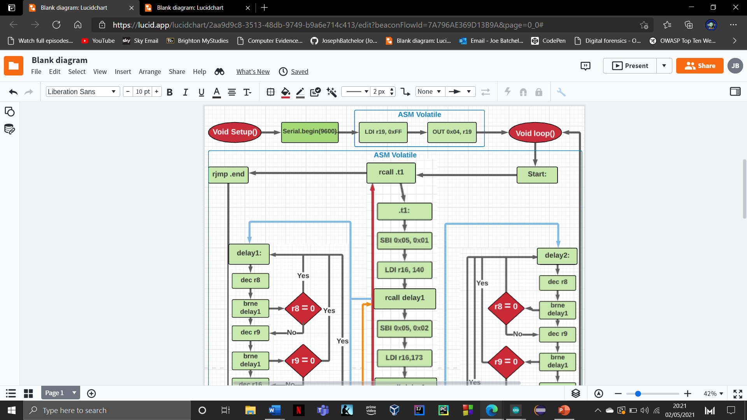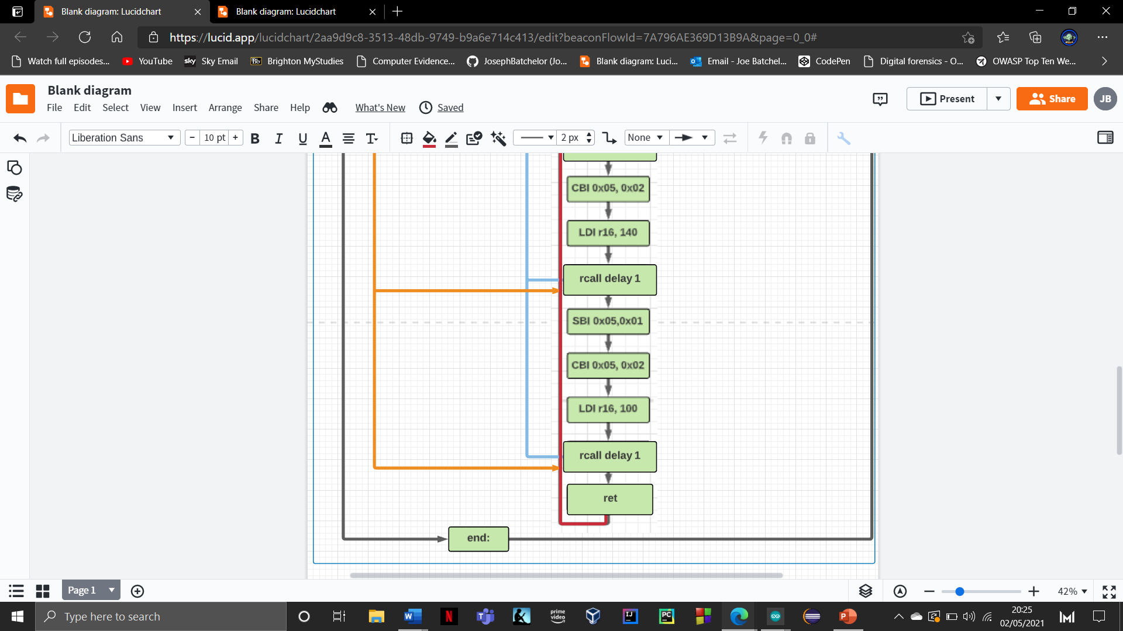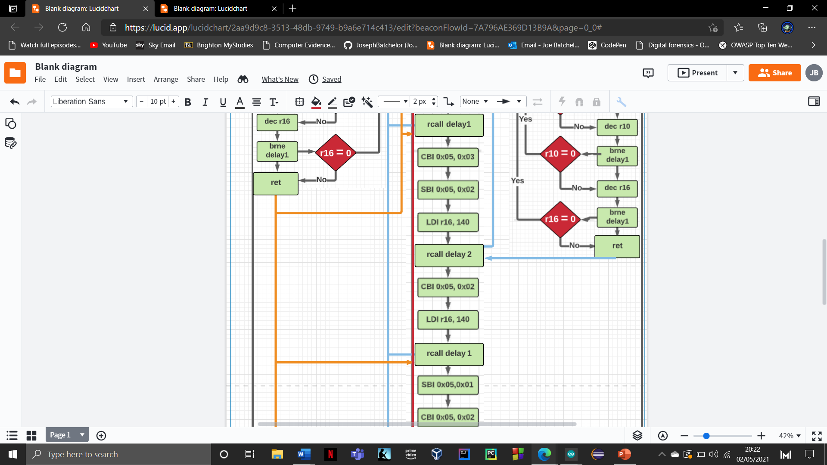

**yes**

**yes**

**yes**

**NO**

**NO**

**yes**

**yes**

**yes**

**NO**

**yes**

**NO**

**NO**

**NO**

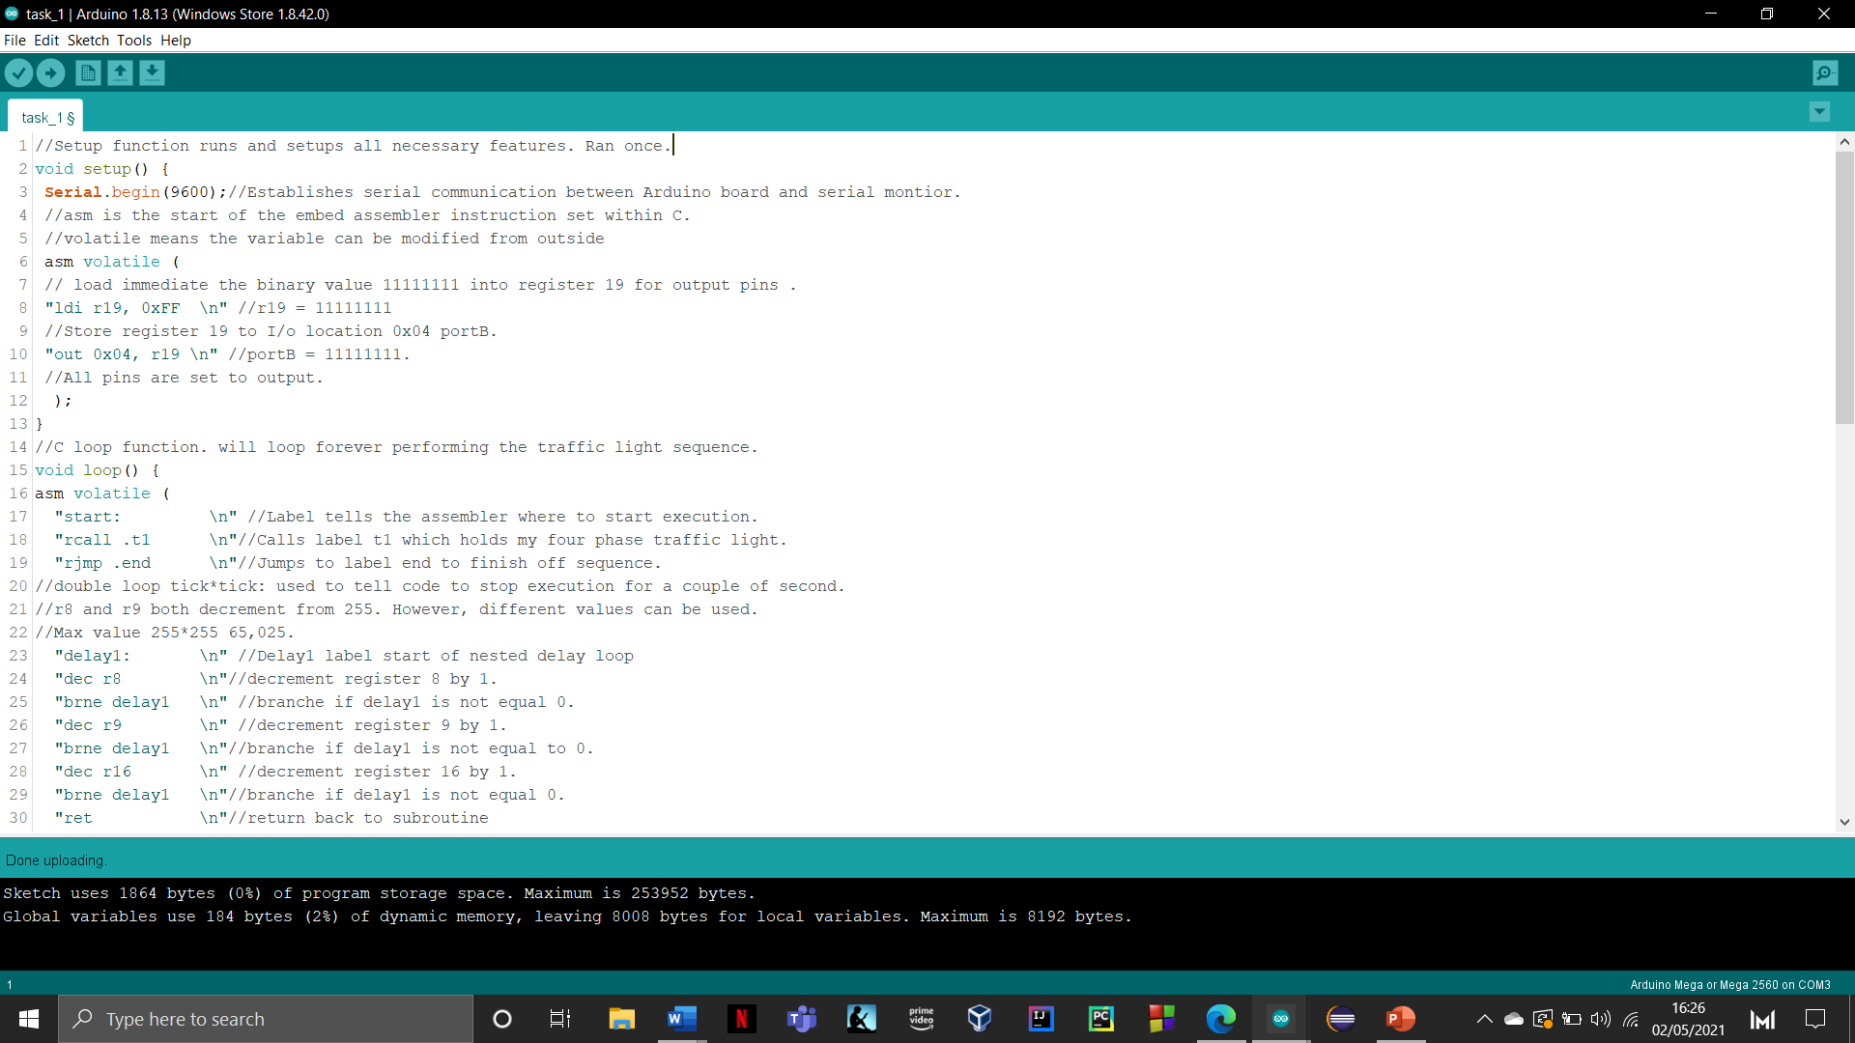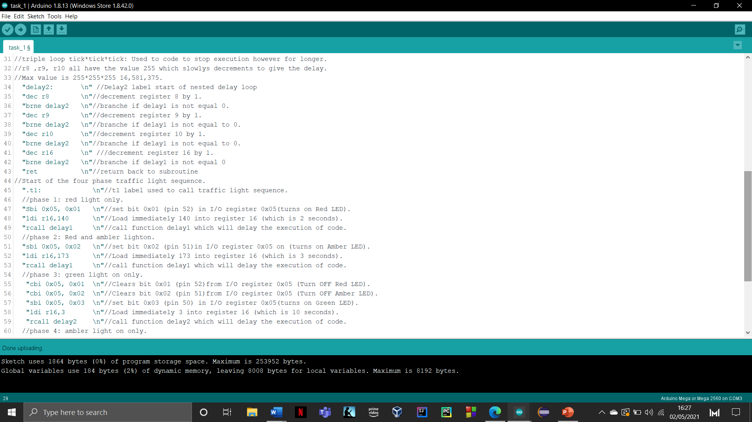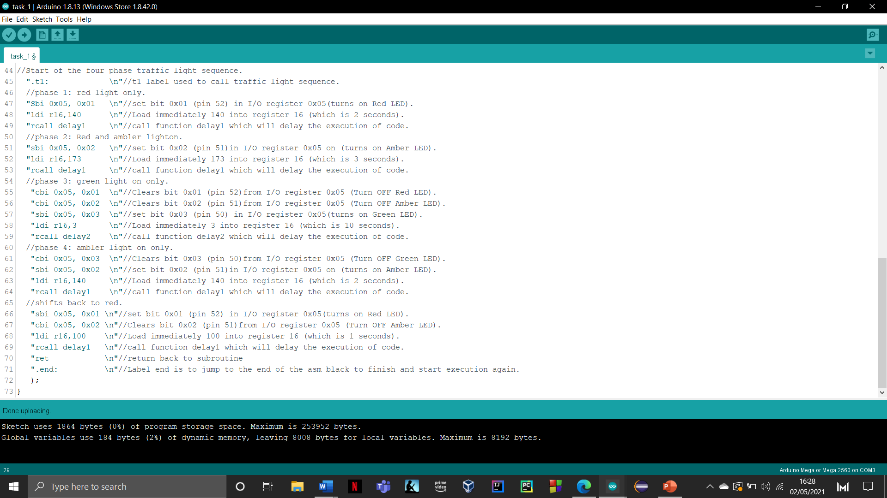

**Task 4:** Implement the developed algorithm and write a programme in assembly to simulate the four-phase traffic Light system.

**Task 5:**Modify the developed algorithm and produce a new flowchart to provide a solution for the operation of a junction with two four phase traffic lights.

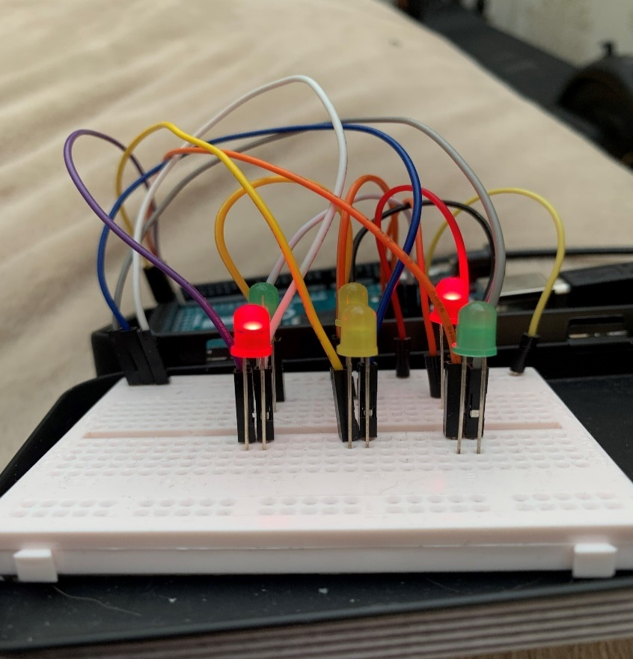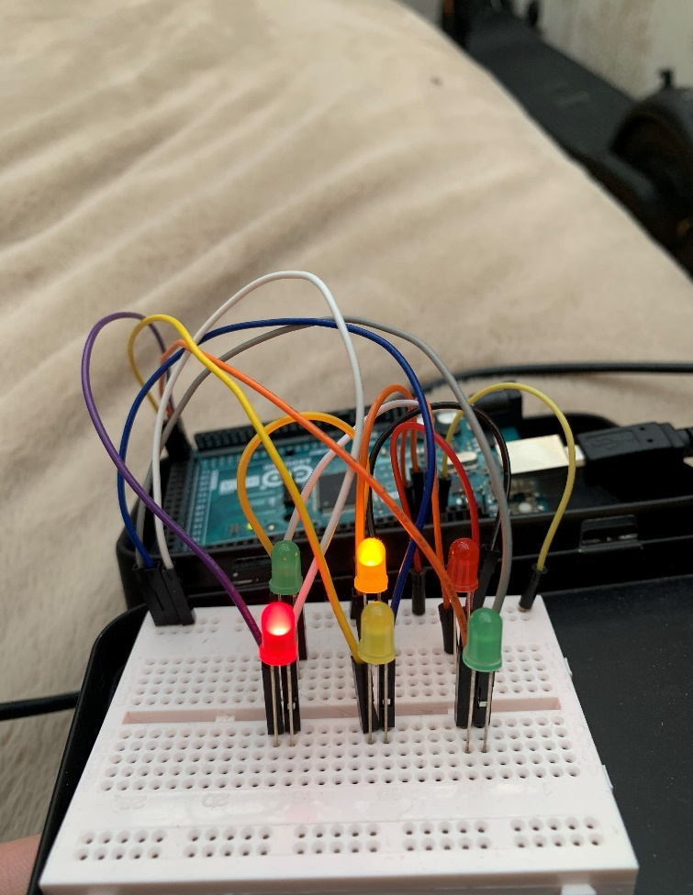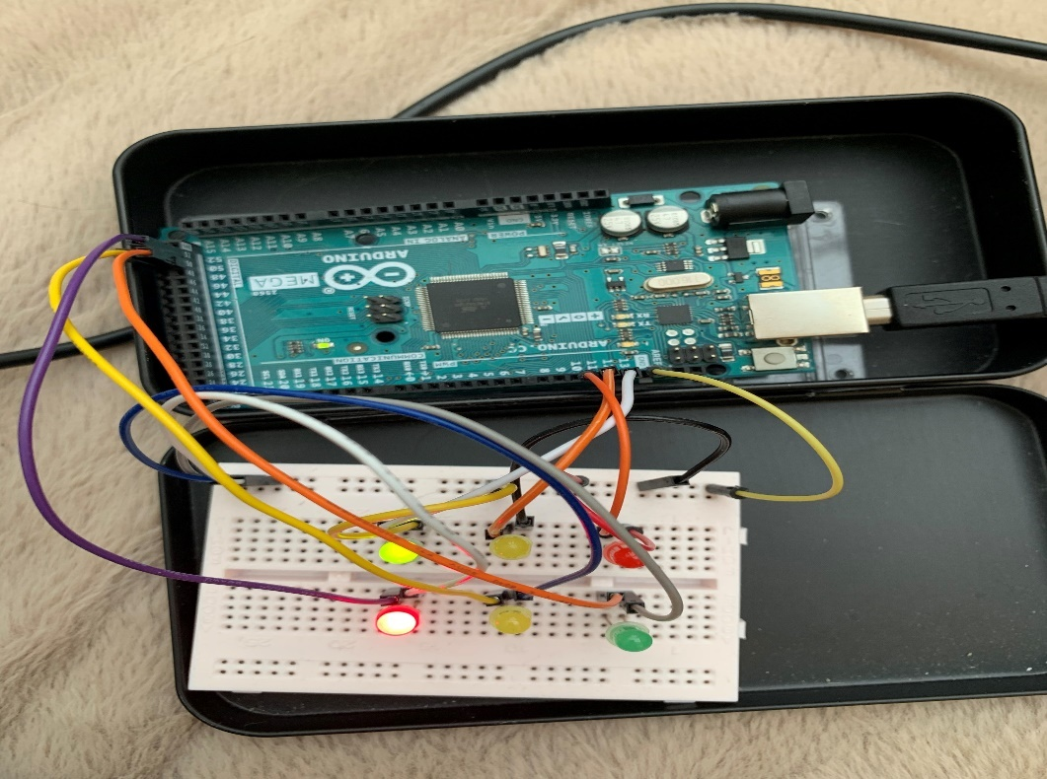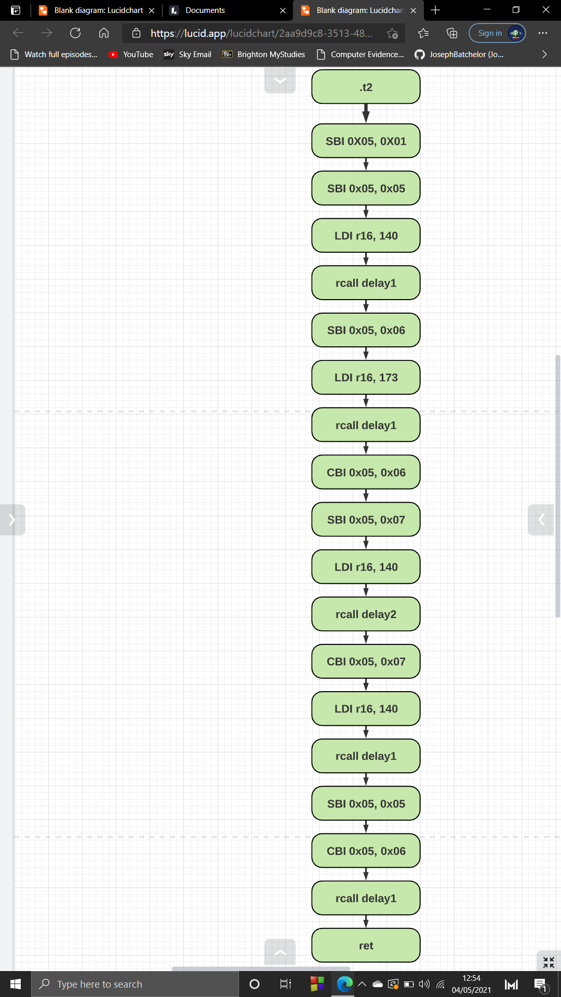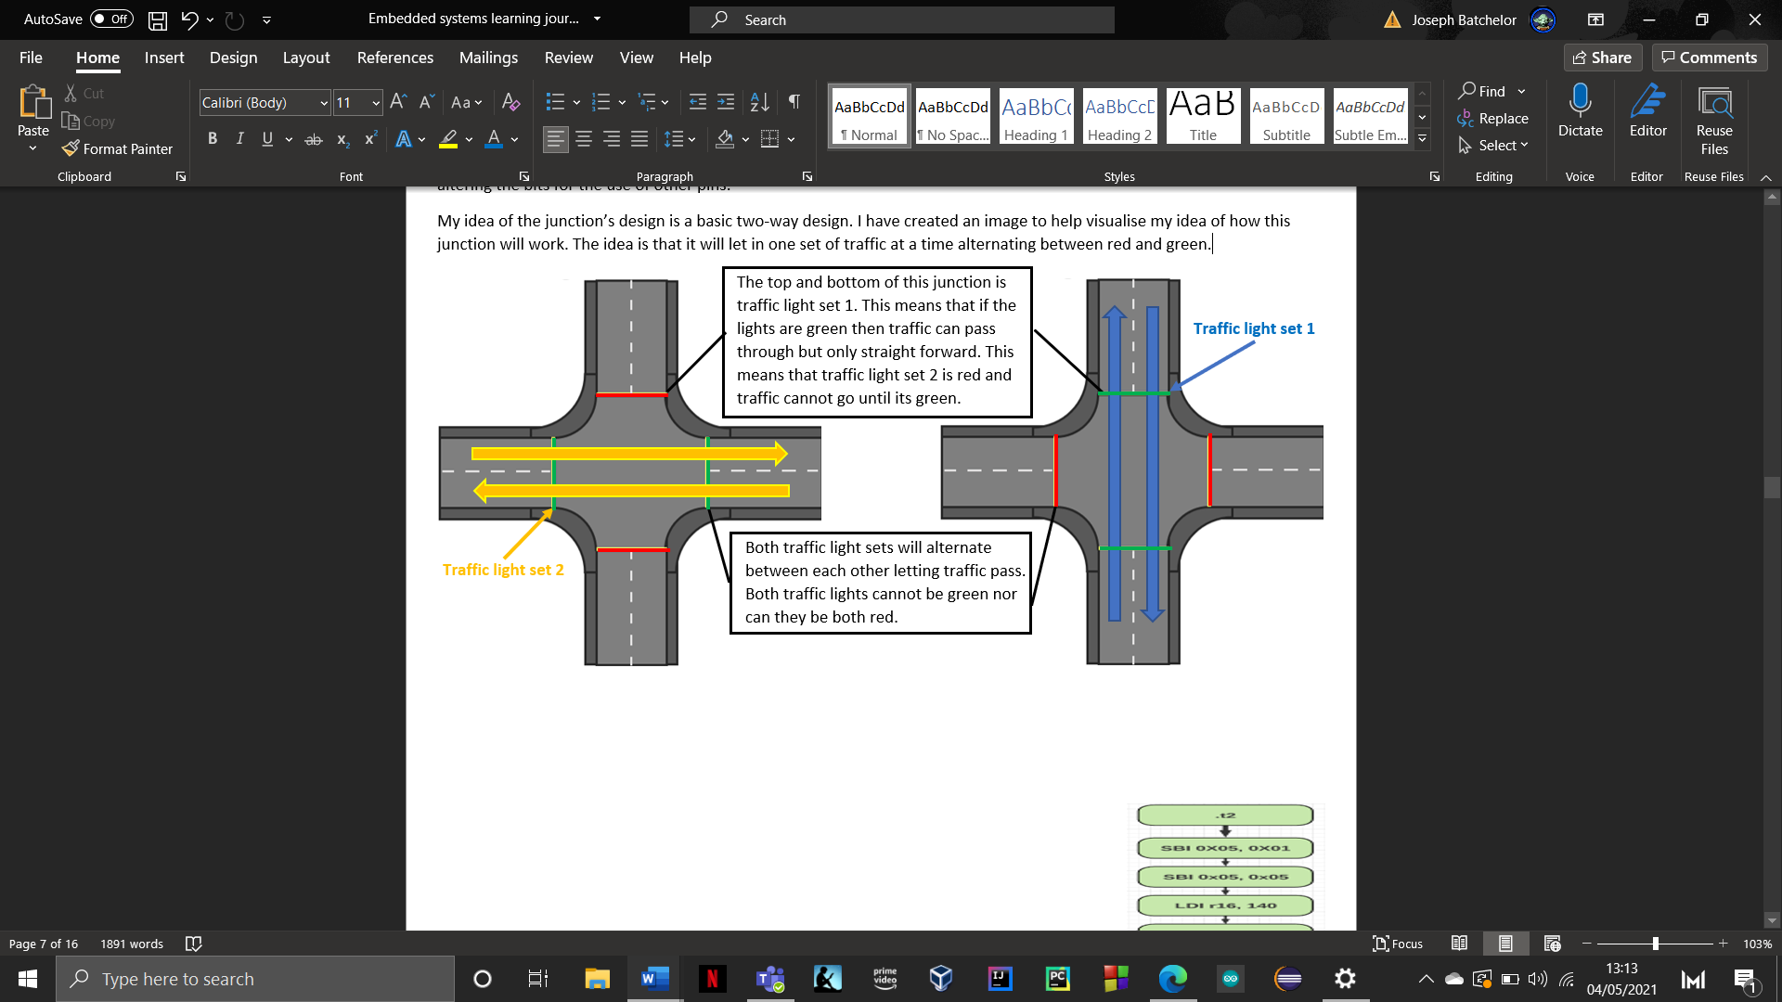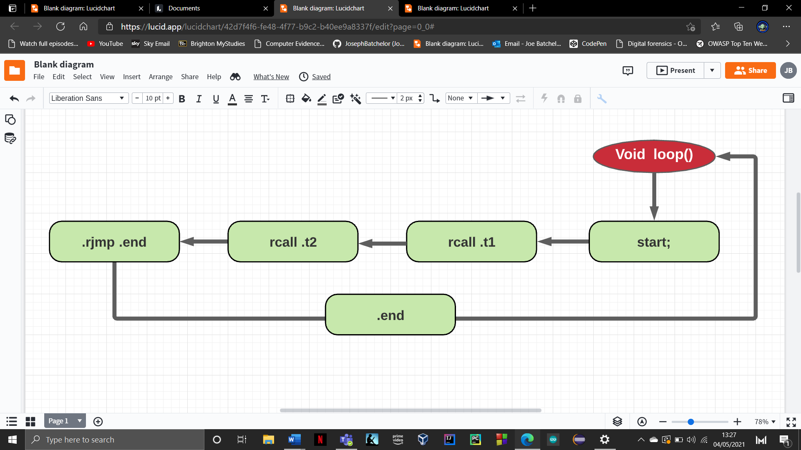This next task requires us to introduce additional code to our already existing four phase traffic light sequence by adding another sequence of lights to create a junction. This approach is as simple as replicating what has already been done and altering the bits for the use of other pins. My idea of the junction’s design is a basic two-way design. I have created an image to help visualise my idea of how this junction will work. The idea is that it will let in one set of traffic at a time alternating between red and green.

Modifying the flowchart was a simple process which required adding an additional function call in function loop. This means that loop will now call and execute .t1 which is traffic light set 1 and then call .t2 which is traffic light set 2. Function .t2 is the next additional set of instruction which will control a different four phase traffic light set. This is the exact same design as .t1 (traffic light set 1) except in order to use different pin I need to change the bit values. So, bit values **0x01, 0x02, 0x03** were replaced with bits **0x05, 0x06 0x07.**  These bits are used to control pins 10,11 and 12 on PORTB. It a simple adjustment which improves the design and functionality. Below are some images which demonstrates the new modify code working.

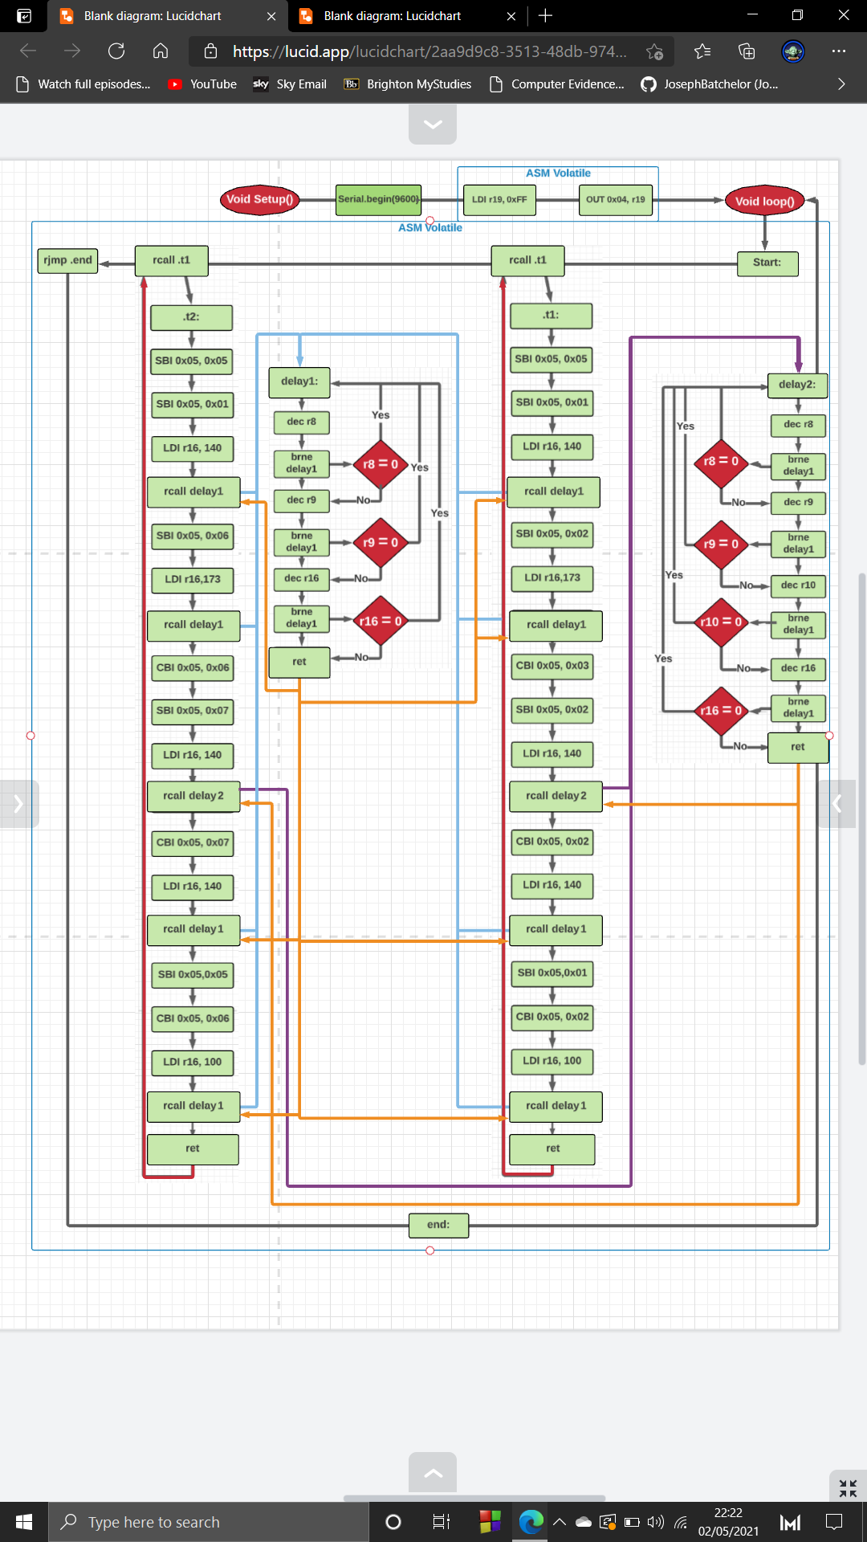

**rcall .t2**

**NO**

**NO**

**NO**

**yes**

**yes**

**yes**

**NO**

**yes**

**yes**

**NO**

**NO**

**yes**

**yes**

This is the complete flowchart design of task 5. This added on the additional changes from the previously.

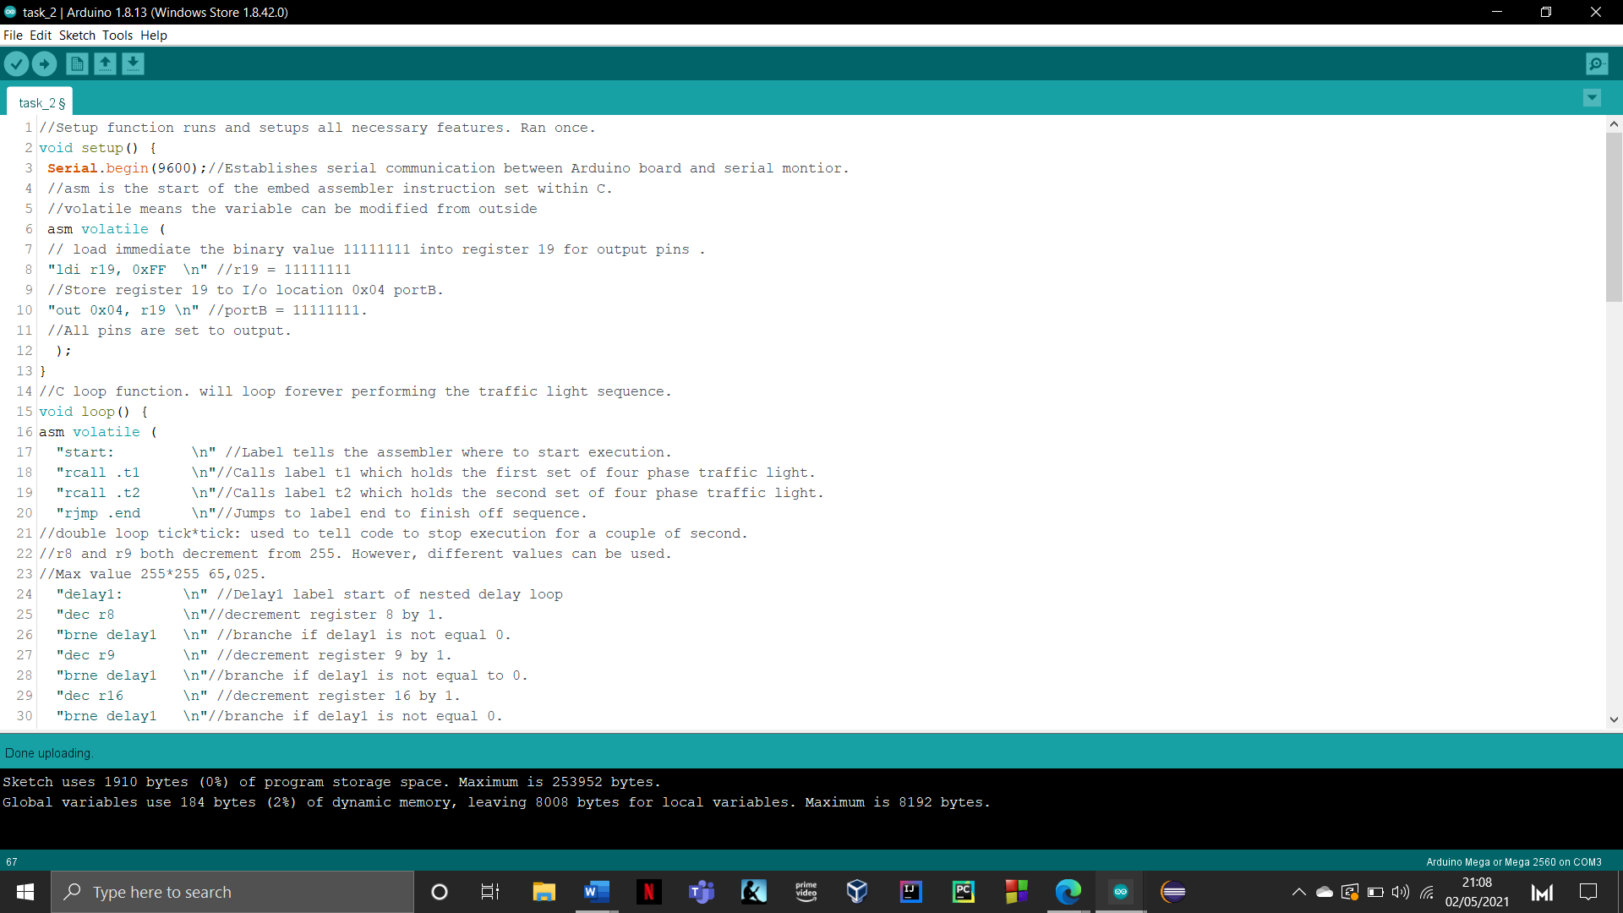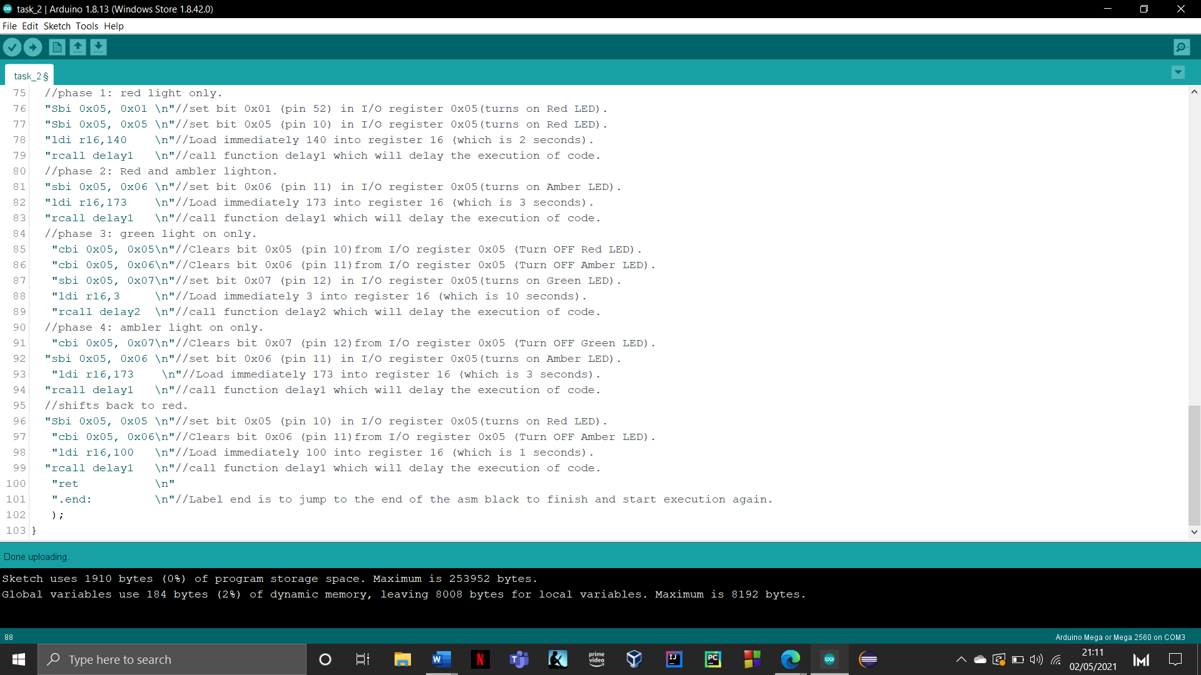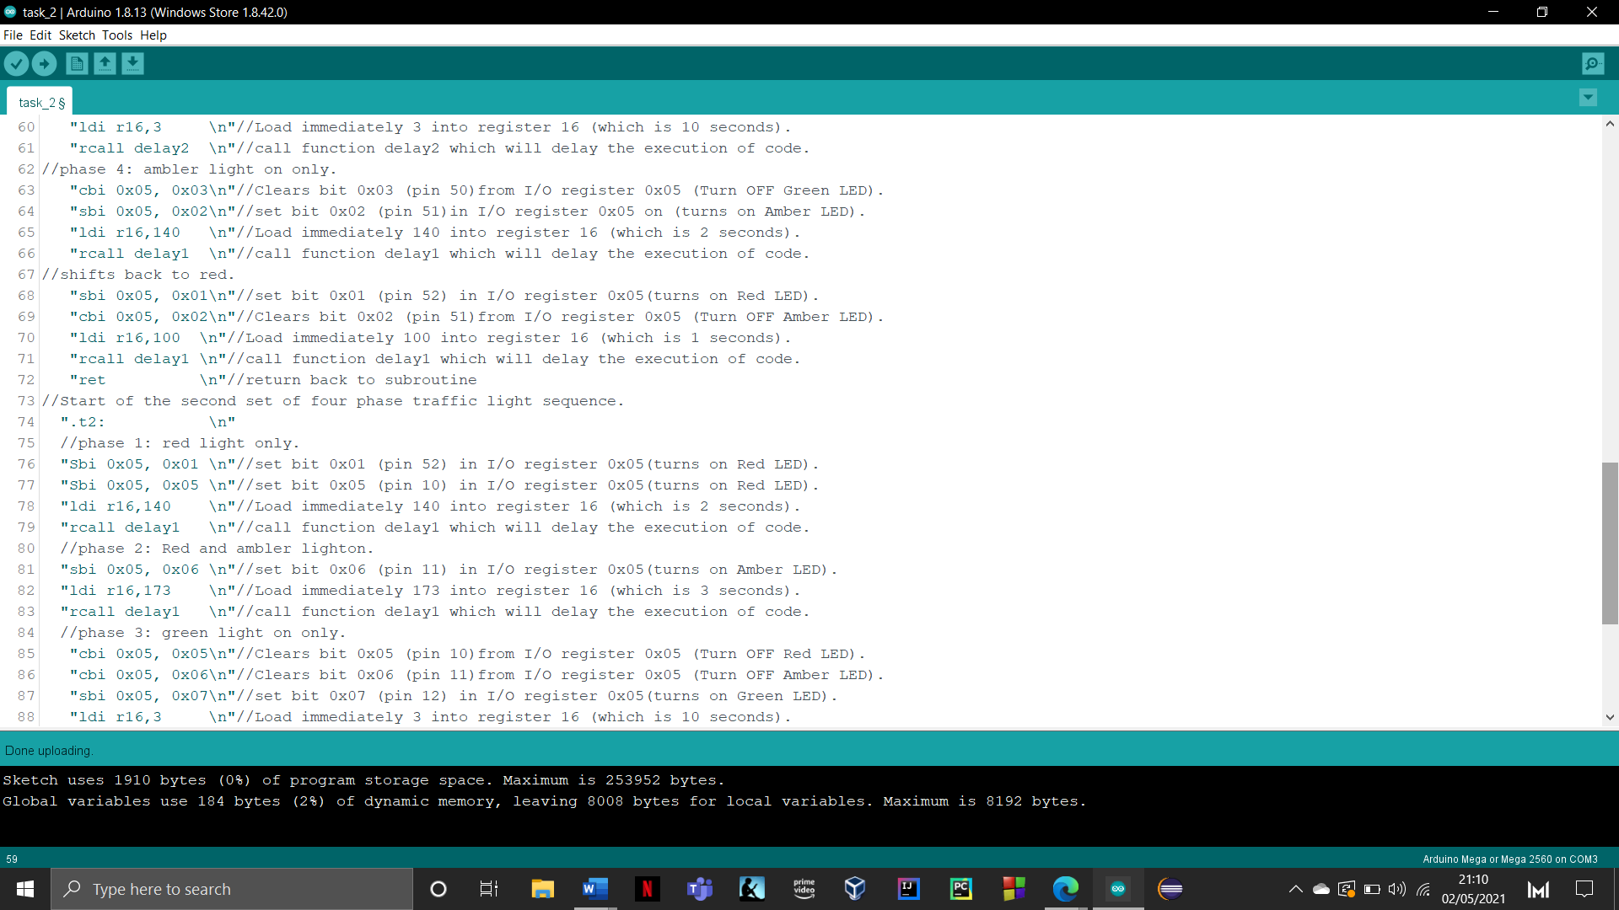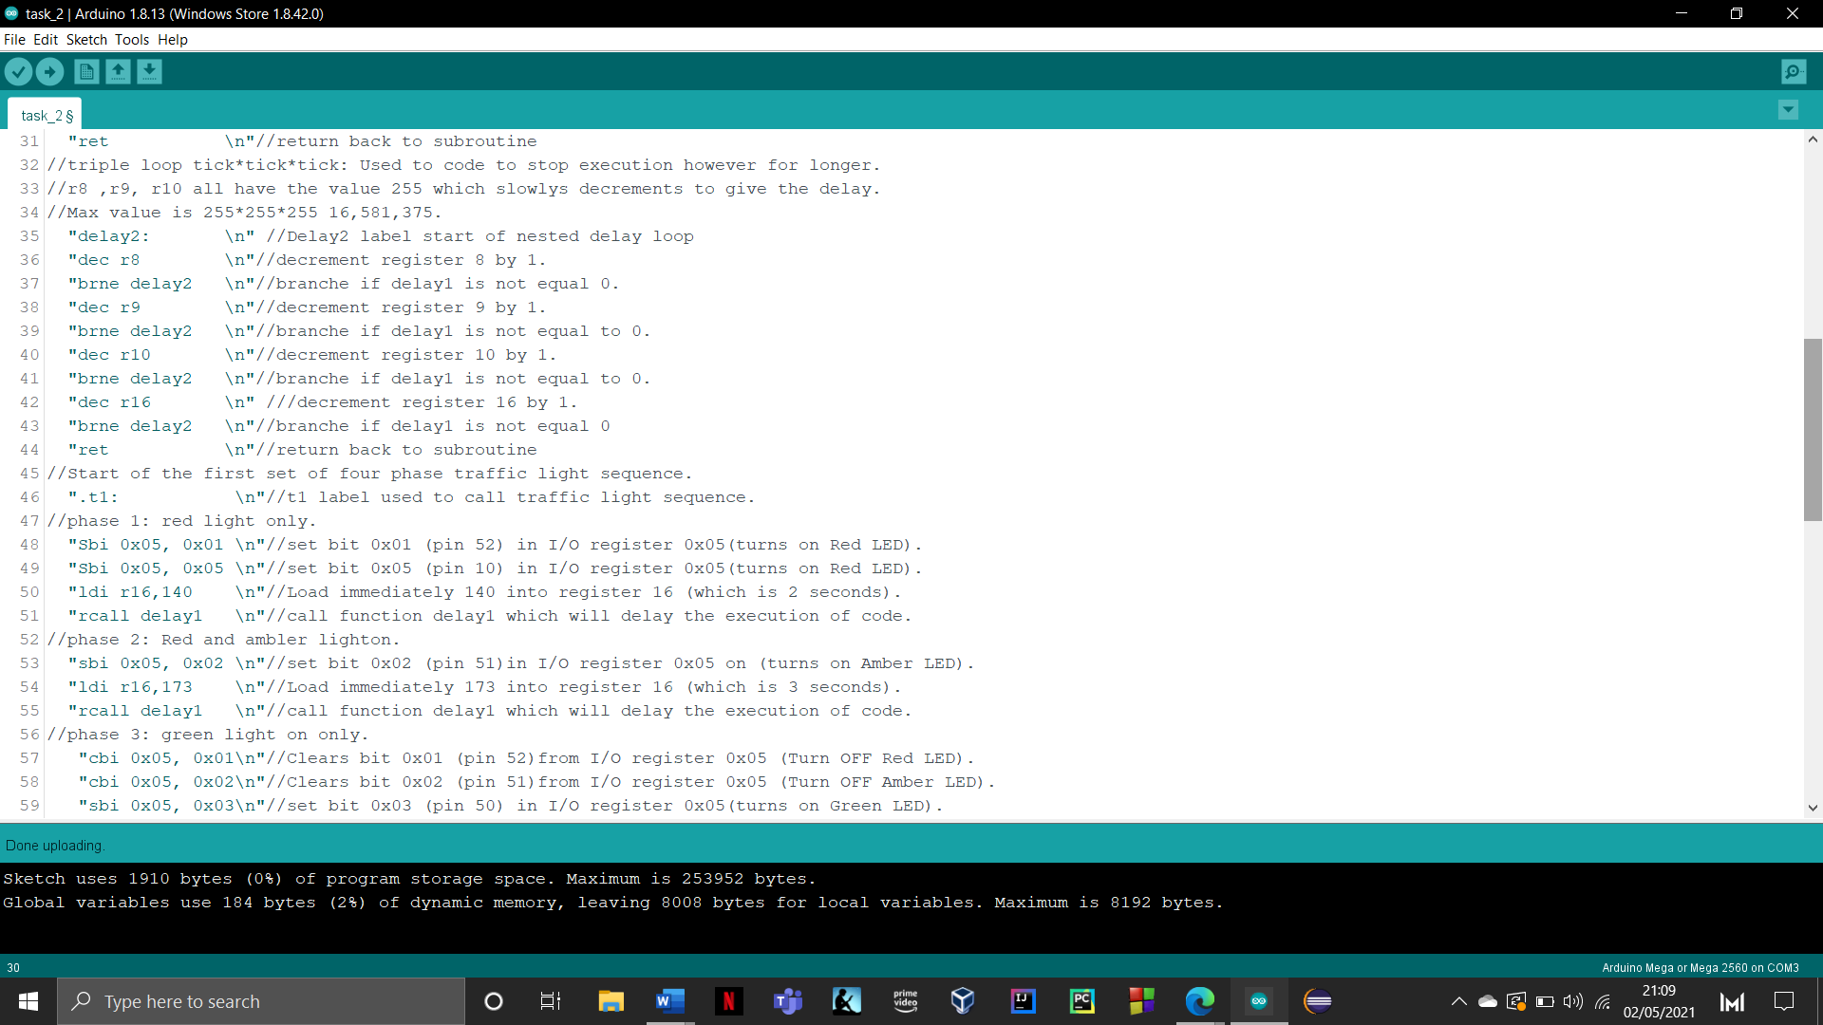

**Task 6:**Implement the modified algorithm in assembly to show its operation.

**Task 7:**Modify the flow chart for the junctions and provide a new flowchart which provides a pedestrian crossing by using a single green LED.

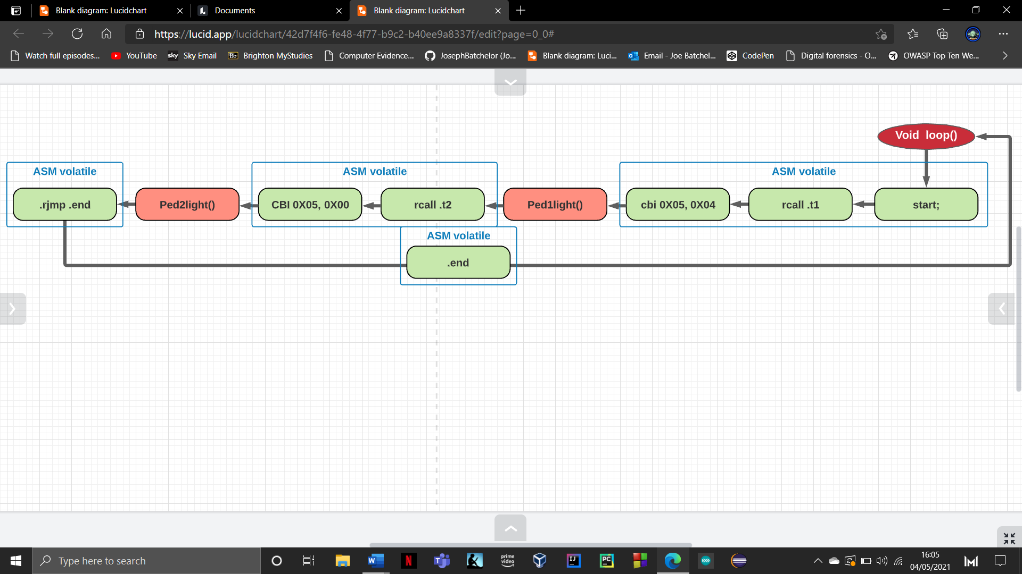This task requires us to implement additional functionality which introduces a pedestrian light for both traffic light sets. This is used to indicate when the pedestrian can cross the road. With the use of two additional green LEDS’s and user input from the serial monitor this will simulate the action of a pedestrian clicking the button to cross the road. With this task the set up with the Arduino will now use 8 pins to illuminate 8 LED’s. Modifying the flow chart was simple as it introduces two new C functions which reads users input and a call to these functions in function loop. Below is the modified loop function and the two implemented C functions.

The alteration made to function loop was simple. This consisted of adding two function calls for each of the pedlight functions. These will determine if user interaction has occurred within the serial monitor. This then will illuminate the pedestrian light to show that a pedestrian has clicked it and is allowed to cross. Additionally, I have added two extra instructions which are **CBI 0x05, 0x04** & **CBI 0x05, 0x01** which is used to turn the opposing pedestrian light off when that traffic light sequence is about to begin.

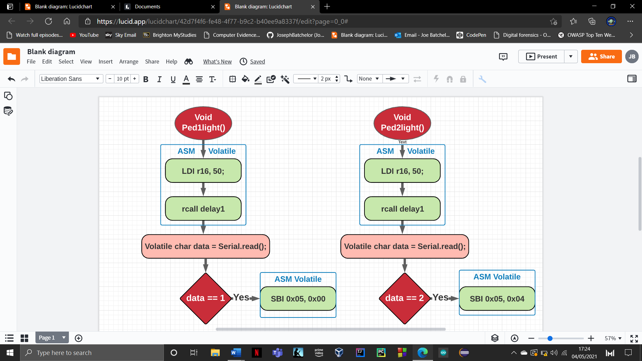

In order to simulate a pedestrian pressing a button I had to incorporate the use of the serial monitor. This will be used to take user input which will trigger pedestrian light on either traffic light.

This was incorporated by introducing two C functions which uses a mixture of embedded assembly and C. unfortunately assembly does not allow for the use of integrated C functions such as serial.read().

Both functions start with half a second delay, this gives the serial.read function time to see if user input has been updated.

Data is a variable which takes the value from the serial.read function and is used in a simple if statement to determine which pedestrian light to turn. This will turn off the correct LED using bit manipulation.

If data is equalled to 1 this turns the pedestrian light on in traffic light set 1 , if equalled to 2 then the ped light on traffic light set 2 is switched on. If neither condition is met, then both lights remain off.

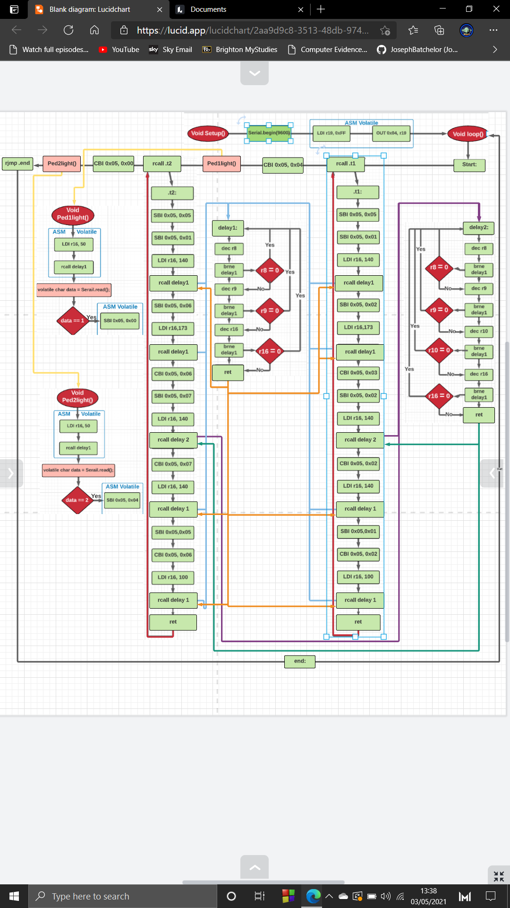This is the updated and complete flowchart for task 7.

**NO**

**NO**

**NO**

**yes**

**yes**

**yes**

**yes**

**yes**

**yes**

**yes**

**NO**

**NO**

**NO**

Task 1 Arduino set up

Below you will see the Arduino set up that allowed me to test and display my code. In total the task consisted of 8 LEDS’s of various colours and 17 pin connectors. Each Junction has its own vertical track on the bread board.

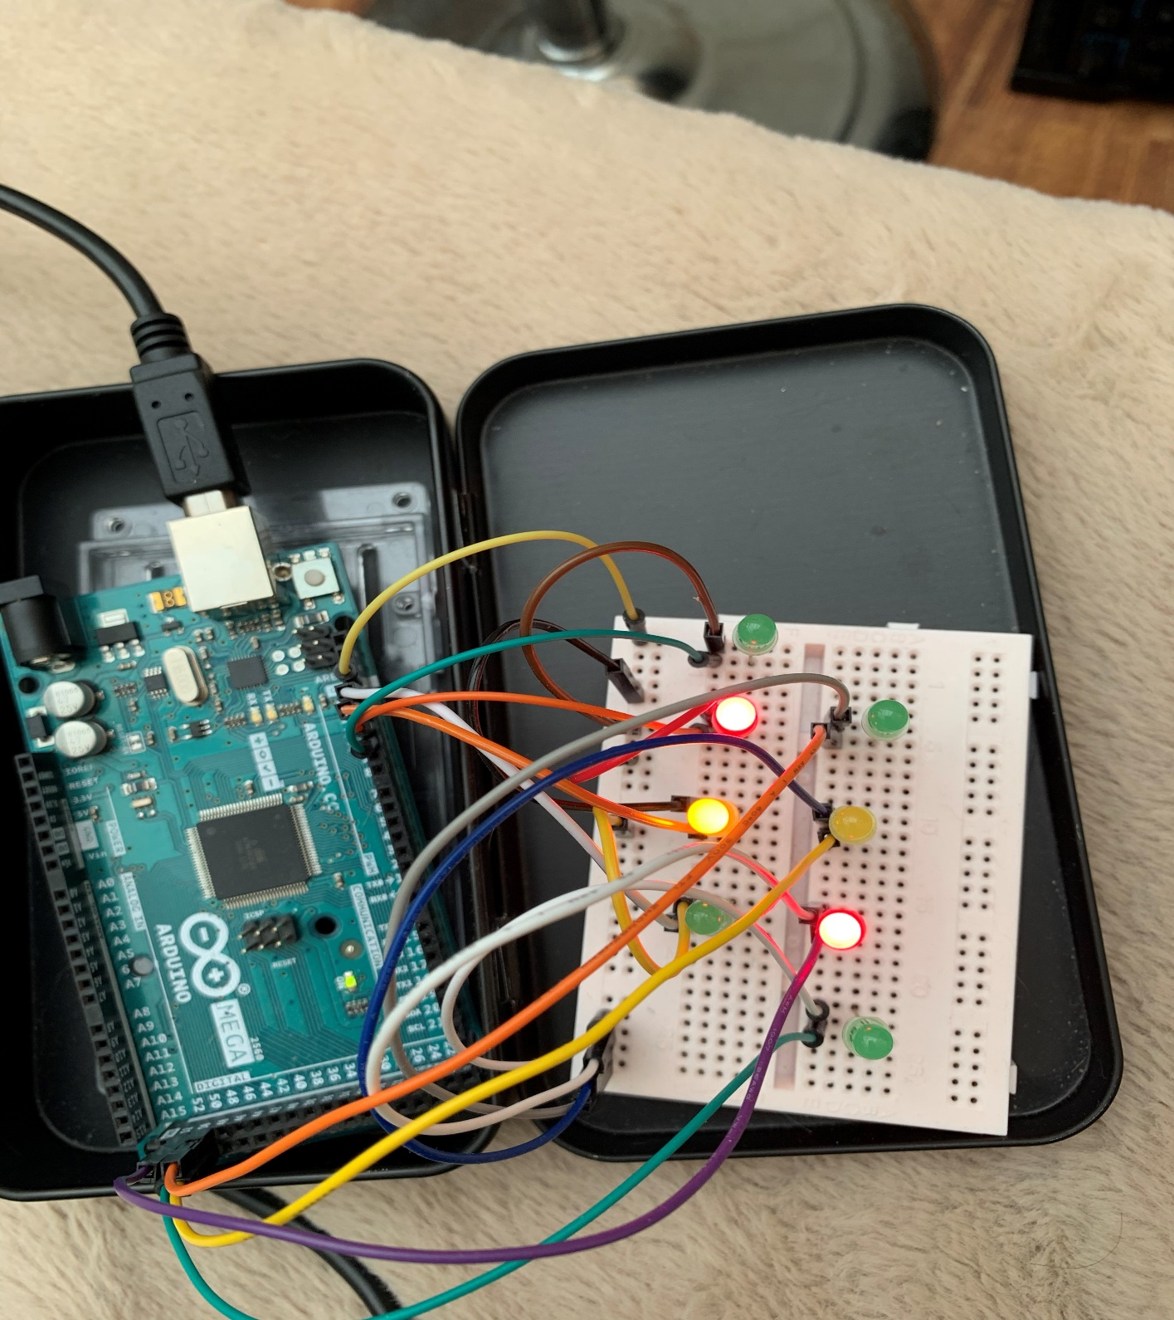

**Traffic Light set 1**

**Traffic Light set 2**

|  |  |  |
| --- | --- | --- |
| **Traffic light** | **Pin** | **Bit value** |
| Green | 13 | 0x07 |
| Amber | 12 | 0x06 |
| Red | 11 | 0x05 |
| Pedestrian | 10 | 0x04 |

|  |  |  |
| --- | --- | --- |
| **Traffic light** | **Pin** | **Bit value** |
| Green | 50 | 0x03 |
| Amber | 51 | 0x02 |
| Red | 53 | 0x01 |
| Pedestrian | 53 | 0x00 |

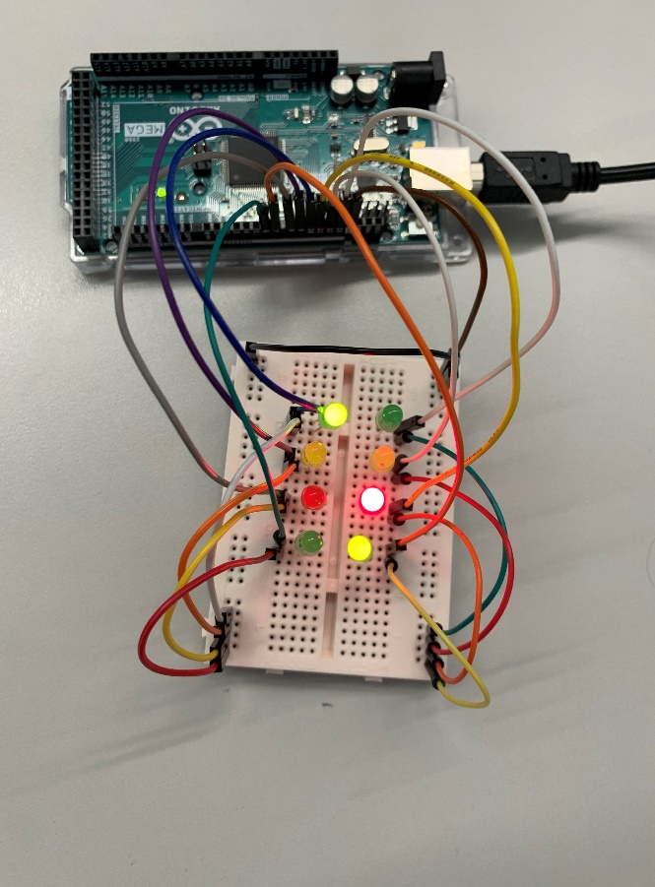Above is an image which highlights the different LEDs used. There are two separate traffic light sets where both use different pins to illuminate the right LED. In order to control the LED’s using assembly instructions this will require the use of bit manipulation.

Along with the image above are two tables which both list which pins each traffic light set uses as well as their bit value.

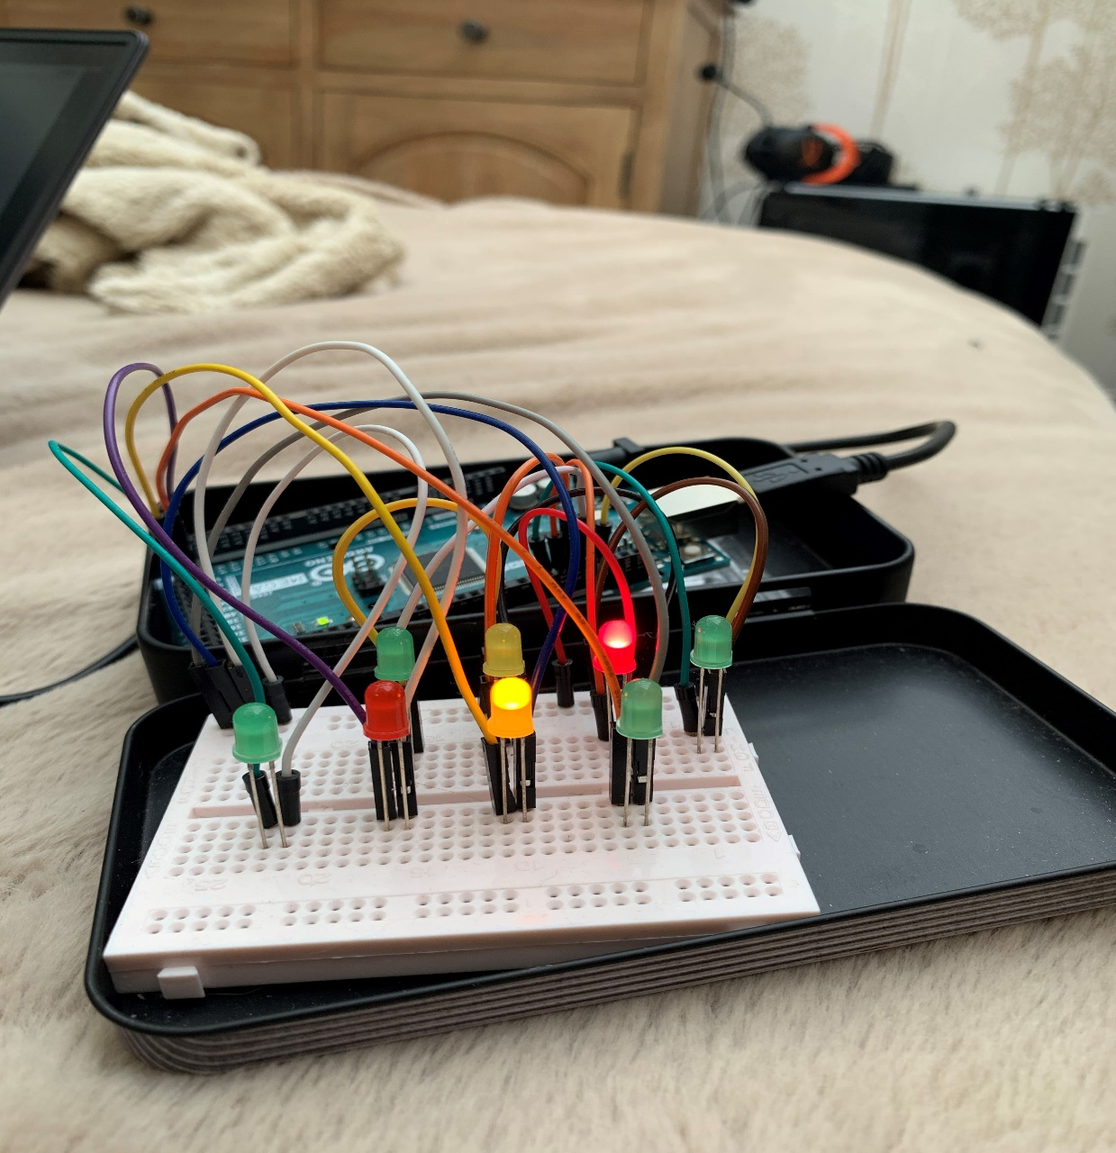Using the Arduino mega manual, you are able to find the necessary information such as the I/O space you need to use. In order to control the LEDS. The I/O space is PORTB which can be referred to as 0x04 which is the hex value.

Overall setting up this task became a tedious one as the number of cables used made it difficult to manage.

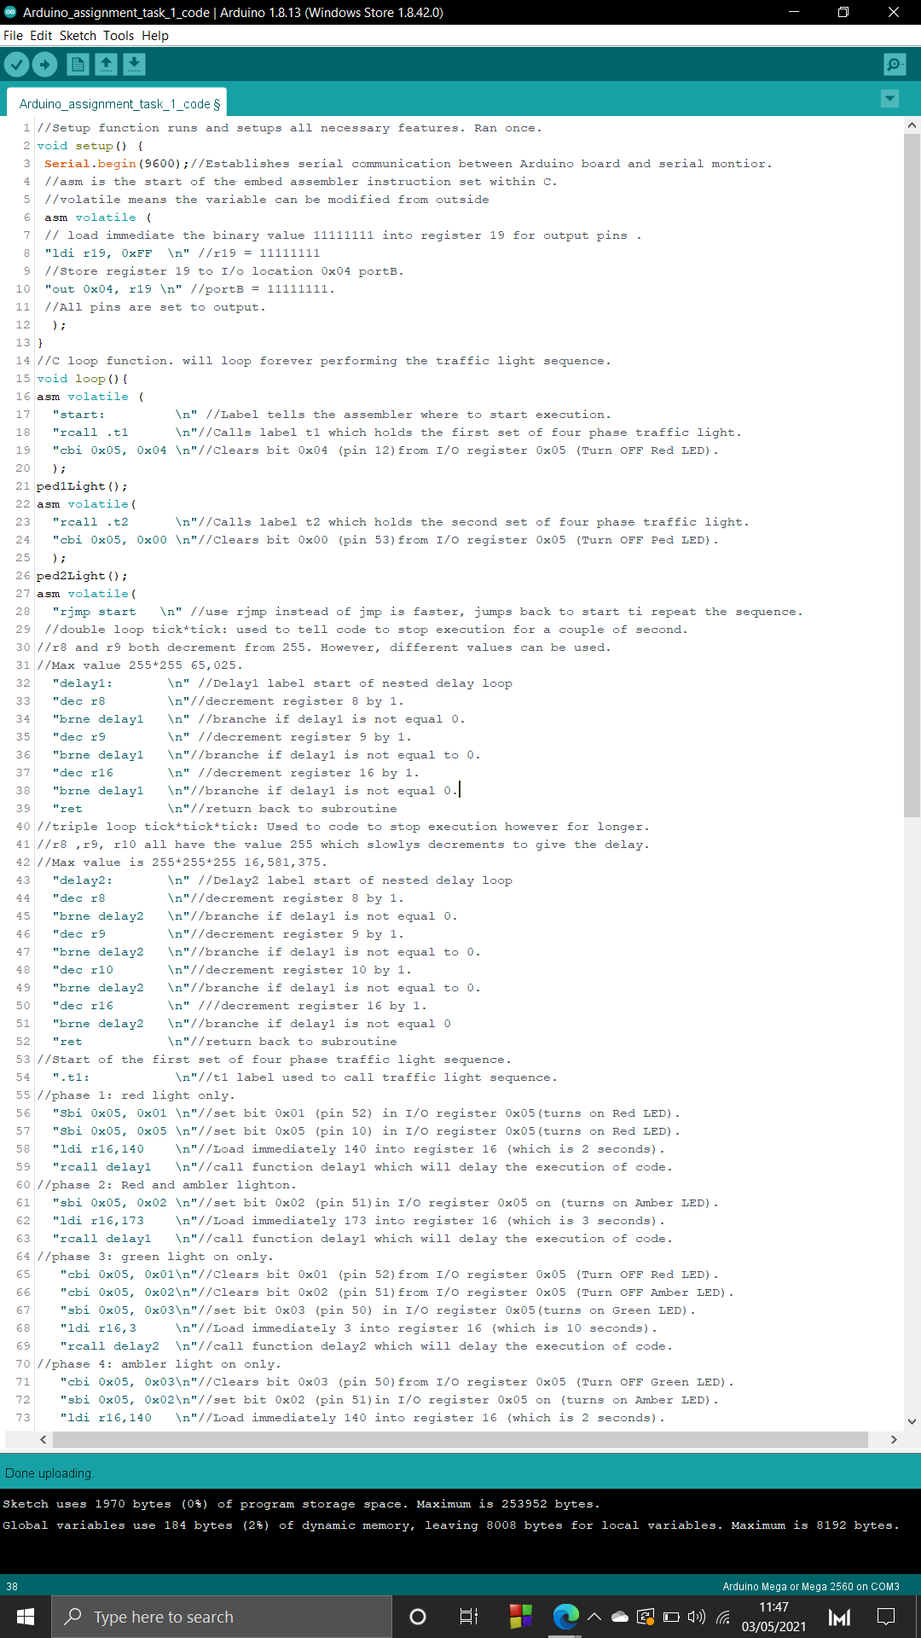**Task 8:** Write an “Assembly” program to implement the new flowchart.

This first section of the traffic light junction code is function setup. This functions is designed to be ran once which will set up the Arduino environment.

This function will set all pins being used to output with the use of the bit manipulation within the inline assembly. By creating a register and storing the binary value 11111111 this will tell the I/O location (0x04) to turn all pins from 0000000 to 11111111, which essentially means on.

We also had to setup the serial monitor to be used for user interaction, this will be used to trigger the correct pedestrian light for when people wish to cross the road. This is done by using the keys 1 &2 which indicate which traffic light the person is at.

****This next section is function loop. This will constantly execute the assembly instruction set which controls the traffic light sequence for both sets. This can be broken down into three areas, the main area is where the assembly code starts, this will call each traffic light sequence and execute the four-phase light sequence both have. The code for .t1 and .t2 are the same except they require different bit values for PORTB, in order to simulate two traffic light sets. The next section contains two assembly delay loops which stops the execution of code depending on the value loaded into register 16. After that is the .t1 & .t2 labels which functions that contain the sequence of lights. This uses LDI, SBI and CBI to turn them on and off the correct LED’s. Once both traffic lights sets are executed within the instruction set this then return back to start an start the sequence again.

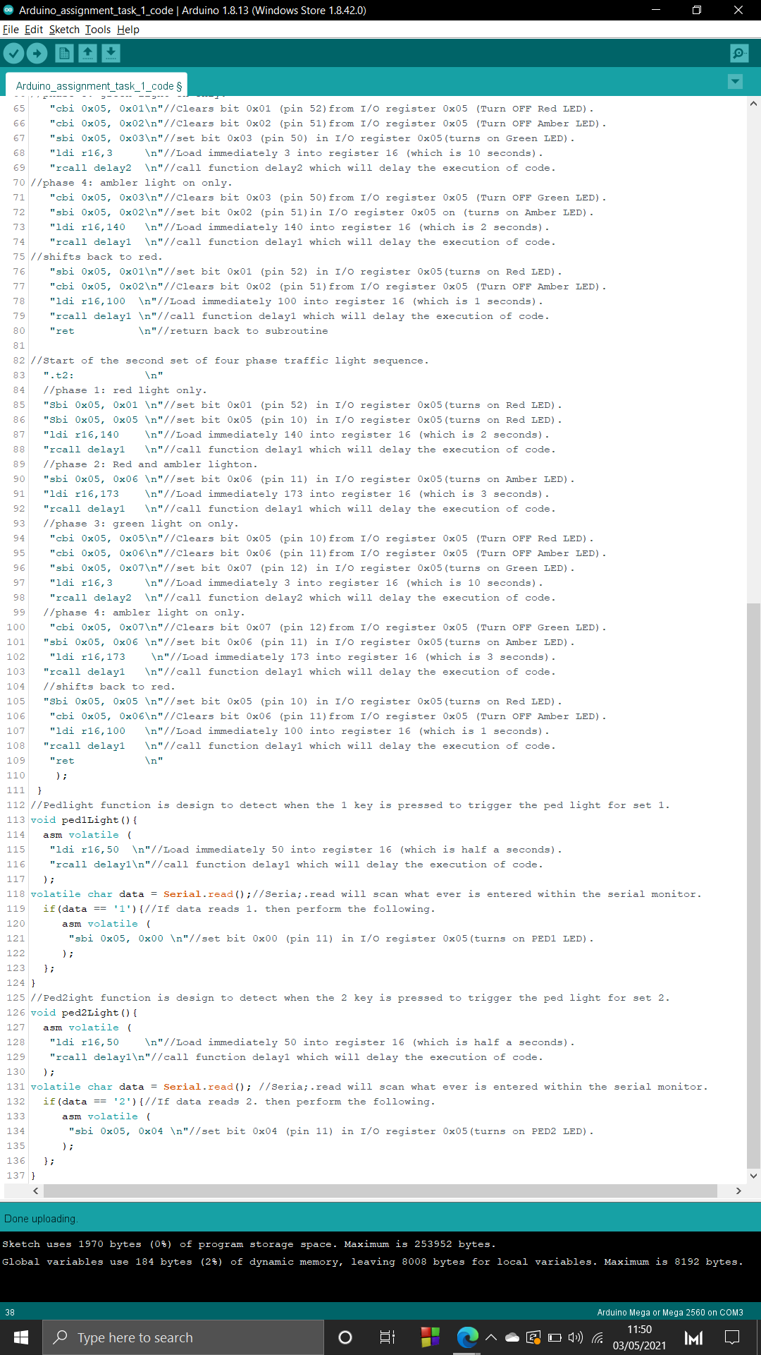This final section are two C functions which have been created to monitor the serial monitor for user interaction. If the user enters in the value 1 (traffic light set 1) or 2 (traffic light set 2) this will simulate a pedestrian pressing the button to cross the road. This will then turn on the pedestrian light after the four-phase sequence has completed itself. This will indicate that the person can cross the road. These two functions uses a mixture of C and assembly code. This due to the fact that user Arduino integrated functions do not partially work within the assembly environment. This is why that the top half of both functions creates a C variable called data which reads the entered value into the serial monitor. This variable is then used in a basic if statement to determine if the LED should be turned on which is done using assembly.

**Task 2: Implement a sorting algorithm using Assembly language**

This task requires me to develop an algorithm that sorts an array of random number in ascending order. This algorithm must be written in assembly language.

Requirements:

1. Obtain an Arduino Uno or Mega Board and connect it to the PC.
2. From the computing programmes select Arduino program.
3. Draw a flowchart of an algorithm which sorts the array in ascending or descending order. The numbers are in the range of 0 to 255.
4. The highest and the lowest numbers in the array should be displayed using eight L.E.Ds.
5. The sorted array should be displayed on the serial monitor using a pointer.
6. The sorting function should be triggered by keyboard input from the serial monitor.
7. The numbers should be randomly generated.

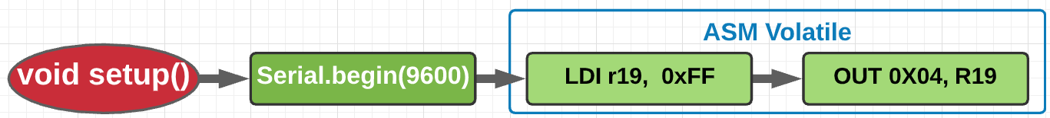The design and idea is based around the bubble sorting method which is where the unordered data set has every value within it compared with each other element deciding which is greater than. Those that are greater are swapped gradually making itself to the top of the data set. Our first task is creating a flow chart of the sorting algorithm below are the different area of the flowchart which is based on the bubble sorting method.

The first flowchart displays method setup which contains specific instructions that is sent to the Arduino that configures which ports are going to be used. Additionally, I have also set up the serial monitor with the use of the of the Arduino function **serial.begin(9600)** this will transfer data to and from the Arduino the value 9600 is to indicate the rate of bits at which data is transferred at. I have also performed bit manipulation by loading immediately **register r19** with the hex value **0xFF**  which means in decimal **11111111**. **Register 19** is then store into I/0 location **0x04** which is PortB. Setting all 8 pins to output.

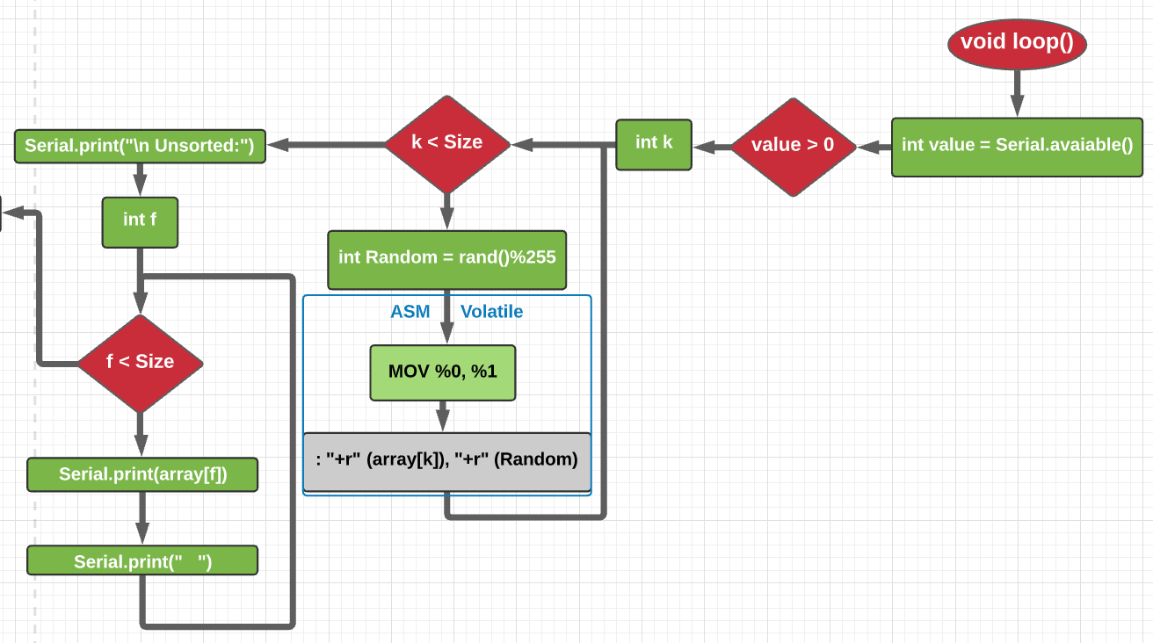

Function loop is used to constantly loop forever generating random numbers to be sorted. Additionally, it holds all the main aspects of this task. As part of the requirements, we must introduce user interaction which triggers the sorting sequence of the random array. This is done by creating a C variable which takes the value from the **serial.read** function. This function will monitor the serial monitor for user interaction which will store the entered value into the variable value. From there it use a basic if statement to determine if the user has interacted with the serial monitor it would see if the value entered is greater then 0. If so, this will start the sorting algorithm.

The next step is populating the array with 15 random numbers. A basic for loop is created which will iterate through the array and store random value in that position. Using a mixture of assembly and C I first created a variable called **Random** which will generate a random number between the **0-255**. Using the method rand() which is a feature of C this will generate a random number. I divided the **rand()** number by the max amount which is **255** and then used "%" to get its remainder which will be less than the max. Storing it in the array was done by adding some assembly which uses two output constraints.

The first one is **array[k]** which is the index position to store the random number, and **Random** which will generate the random number. Both constraints use **"+r"** which will use any register 0-31 and reuse the same memory location for input and output. The way this store random value is by using the **MOV** mnemonic. This instruction makes a copy of one register into another, the source of the register remains unchanged while the destination register is loaded with a copy of the source. **MOV %0, %1** means move **Random** into **array[k]. %0** and **%1** are the call to the listed constraints **0** is the **array[k]** as it is the first and **1** is **Random**.

The last part of this flowchart is a simple for loop which iterates through the newly populated array and displays the unsorted array onto the serial monitor.

Words

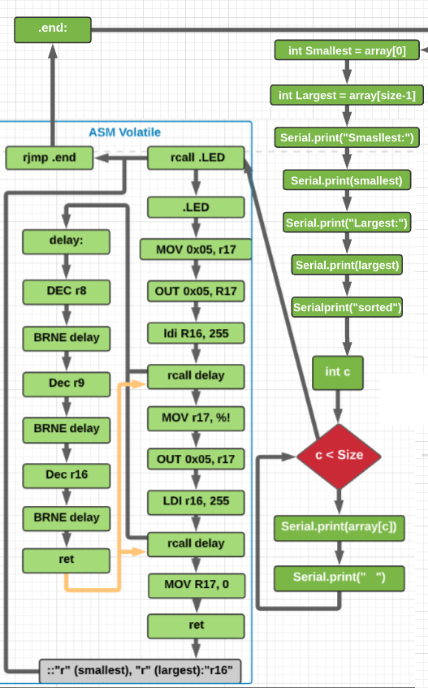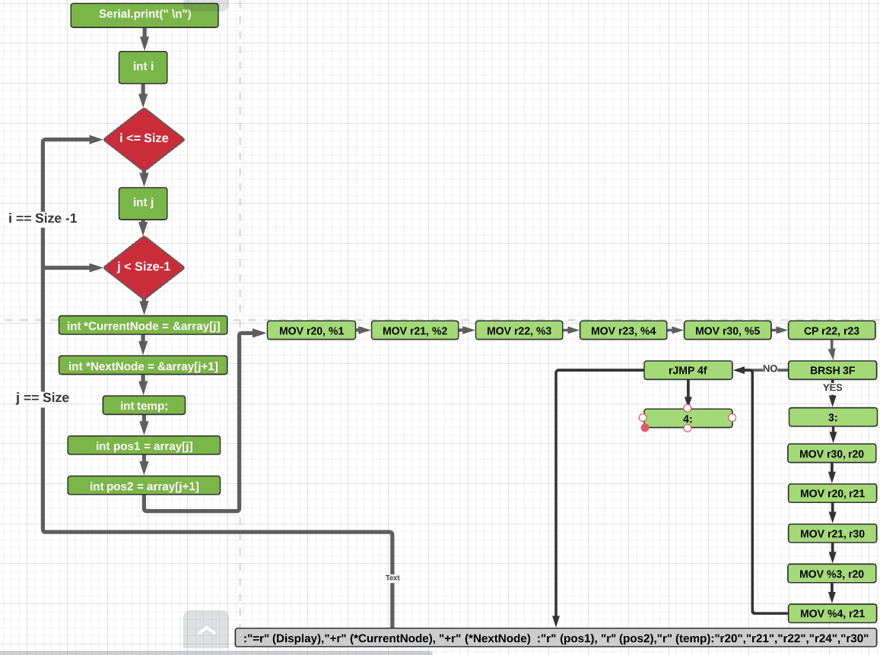

This is the final part of function loop and the algorithm as a whole. Another task we had to incorporate is the ability to display both the smallest and largest values within the array in 8 bit binary using LED’s.

This was a simple task using assembly, as after the array has been sorted and the serial monitor displays both the smallest and largest values as well as the newly sorted array. Two C variables are created which stores the smallest and largest values using the array index. Both of these variables will be placed into **Register 17,** this is done using two input constraints.

**Register 17** is then used with the mnemonic **OUT** which will store data from a register into a I/O space which will be **PORTB.**

A unique design of the Arduino architecture is that the I/O space **0x05** (**PORTB**) is split into 8 bits (0-7) which is a similar layout to binary by storing a number to **0x05** this will then convert the decimal format into binary format which is then used for bit manipulation. This can be used to illuminate the correct LED’s corresponding to the decimal number.

This part of the code will light up the correct LED’s for both the smallest and largest and sperate them with the use of a delay loop. Once they have both been displayed **rjmp .end**  will jump to the bottom of the instruction set where the end label is to restart the loop to sort and display a new arrangement of numbers.

This next part of function loop is the bubble sort. Using two for loops this will iterate through the array 210 times moving and swapping values so that they are in ascending order. Within the inner loop I have created five variable which will be used within my sorting algorithm. **\*CurrentNode** & \***NextNode** will store the address of the index value and its neighbouring value. **Temp** will be used to hold the current node value when they are swapping. **Pos1** & **Pos2** Each of the variables are stored in different registers using **MOV** mnemonic . Register **22** (**Pos1**) and **23** (**Pos2**) and compared using the mnemonic **CP** , this instruction performs a compare between two registers to determine a conditional branch. Pair with the mnemonic **BRSH** is a condition which will branch to a label if the comparison is the same or higher. This means that **pos1** (r22) & **Pos2**(r23)will branch to label **.3** if **pos1** is the same or higher than **Pos2** else it will need perform a **rjmp** to label .4 which does nothing. This will keep on comparing values until all iterations of the loop have been completed or the array has been sorted. In total this instruction set uses Six different input and output constraints. Constraints allow us to integrate C variables into assembly code. These can be found the bottom of instruction sets. They are set out like **Code**:**Output**:**Input**:**Clobbers.**

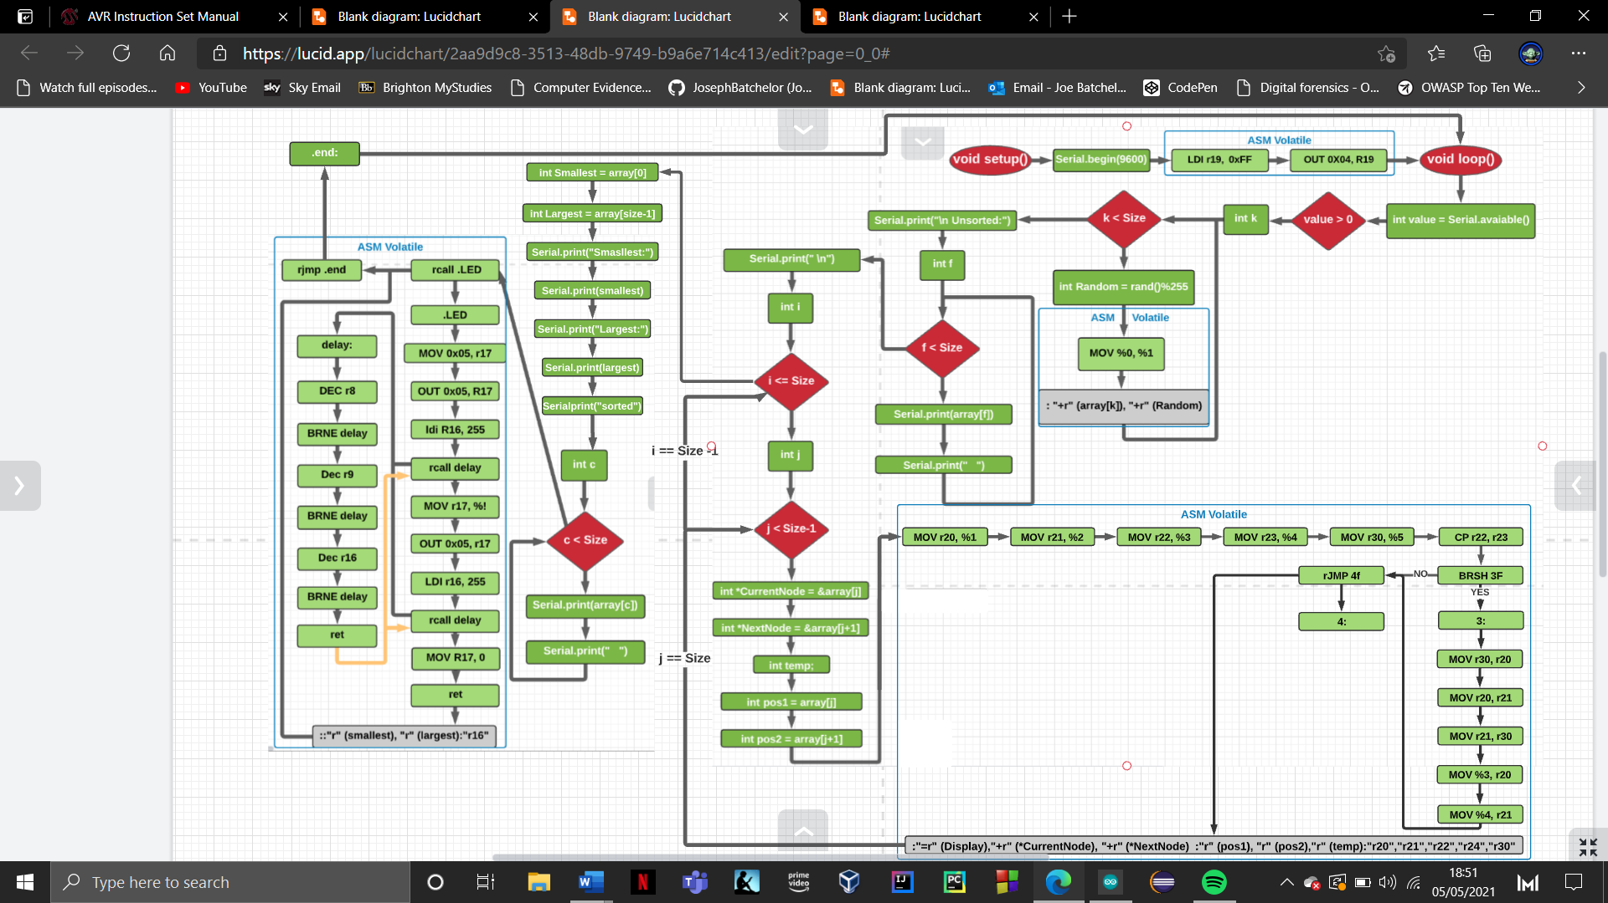

Task 2 Arduino set up

This section discusses the actual design and build of the Arduino. The build includes 8 LEDs and 17 pin connectors. The images below show the arrangement I used to display the values in binary format.

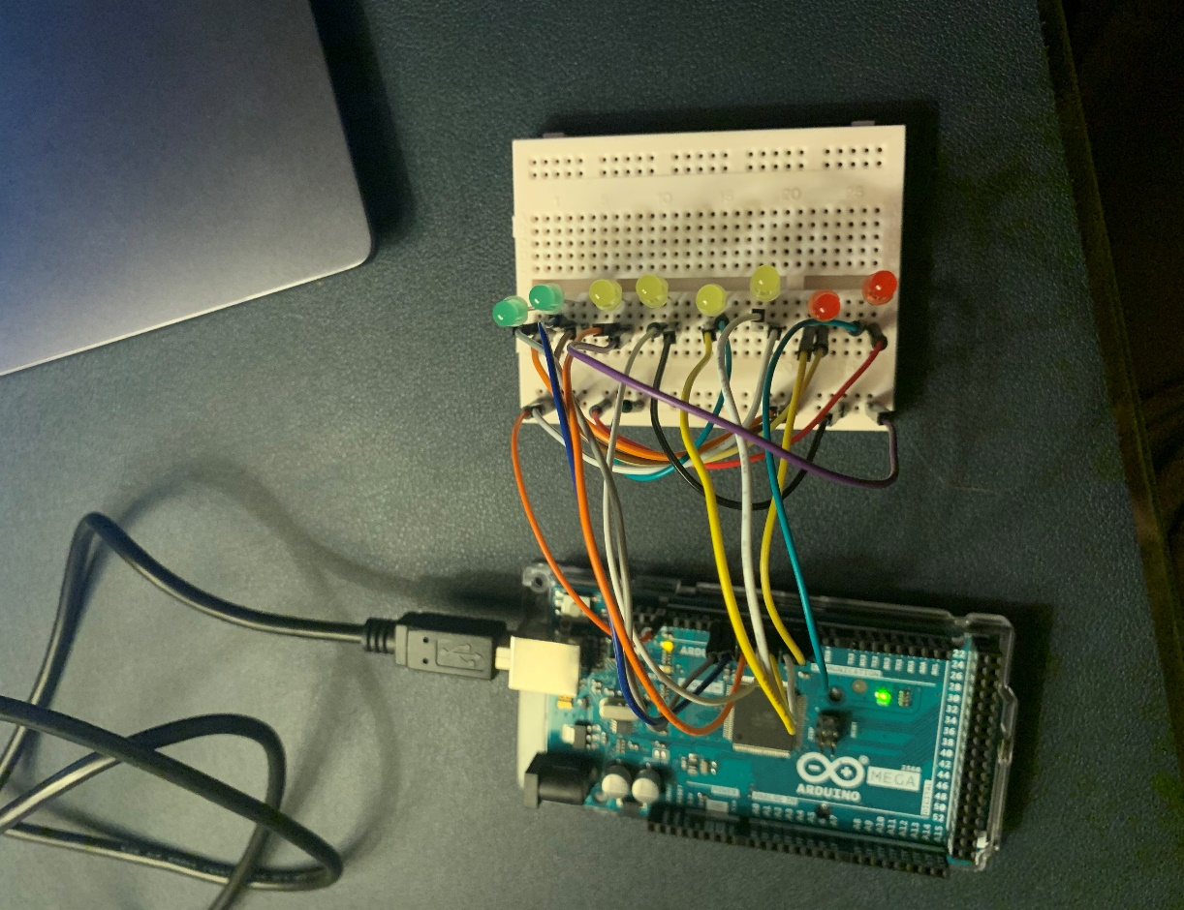

As you can see in the image, I have aligned 8 LED’s in in a line to simulate an 8-bit binary sequence. Starting within the right most LED this would have the value of 1 then the next would be 2 then 4,8,16,32,64 and128 being the finale LED.

Using pins 13, 12, 11, 10, 50, 51, 52 and 53 allowed me to control and display the correct LEDs in assembly.

The way this was done was storing decimal values into PORTB which automatically converts them into binary. This was then used to display the correct LEDS.

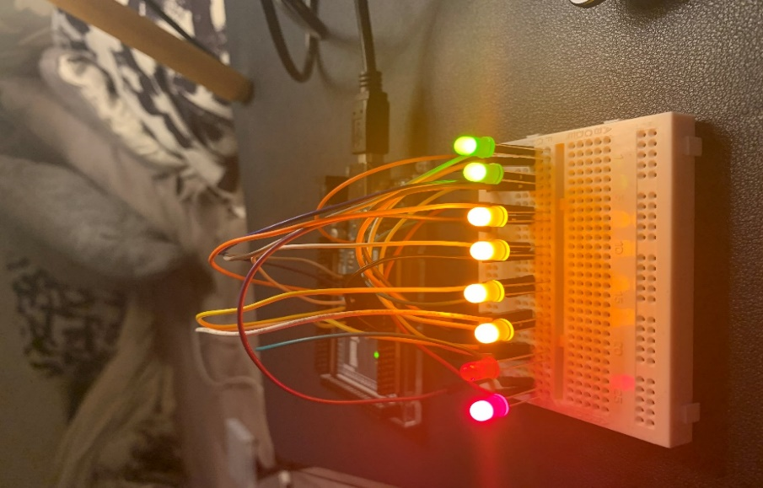

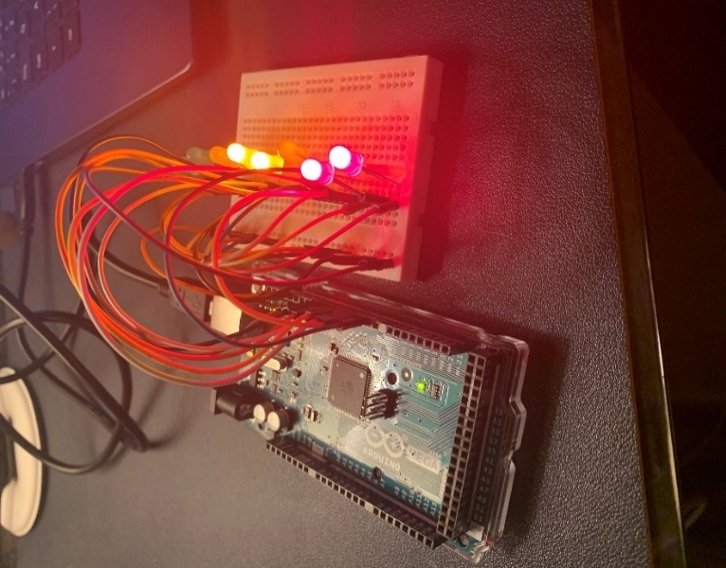

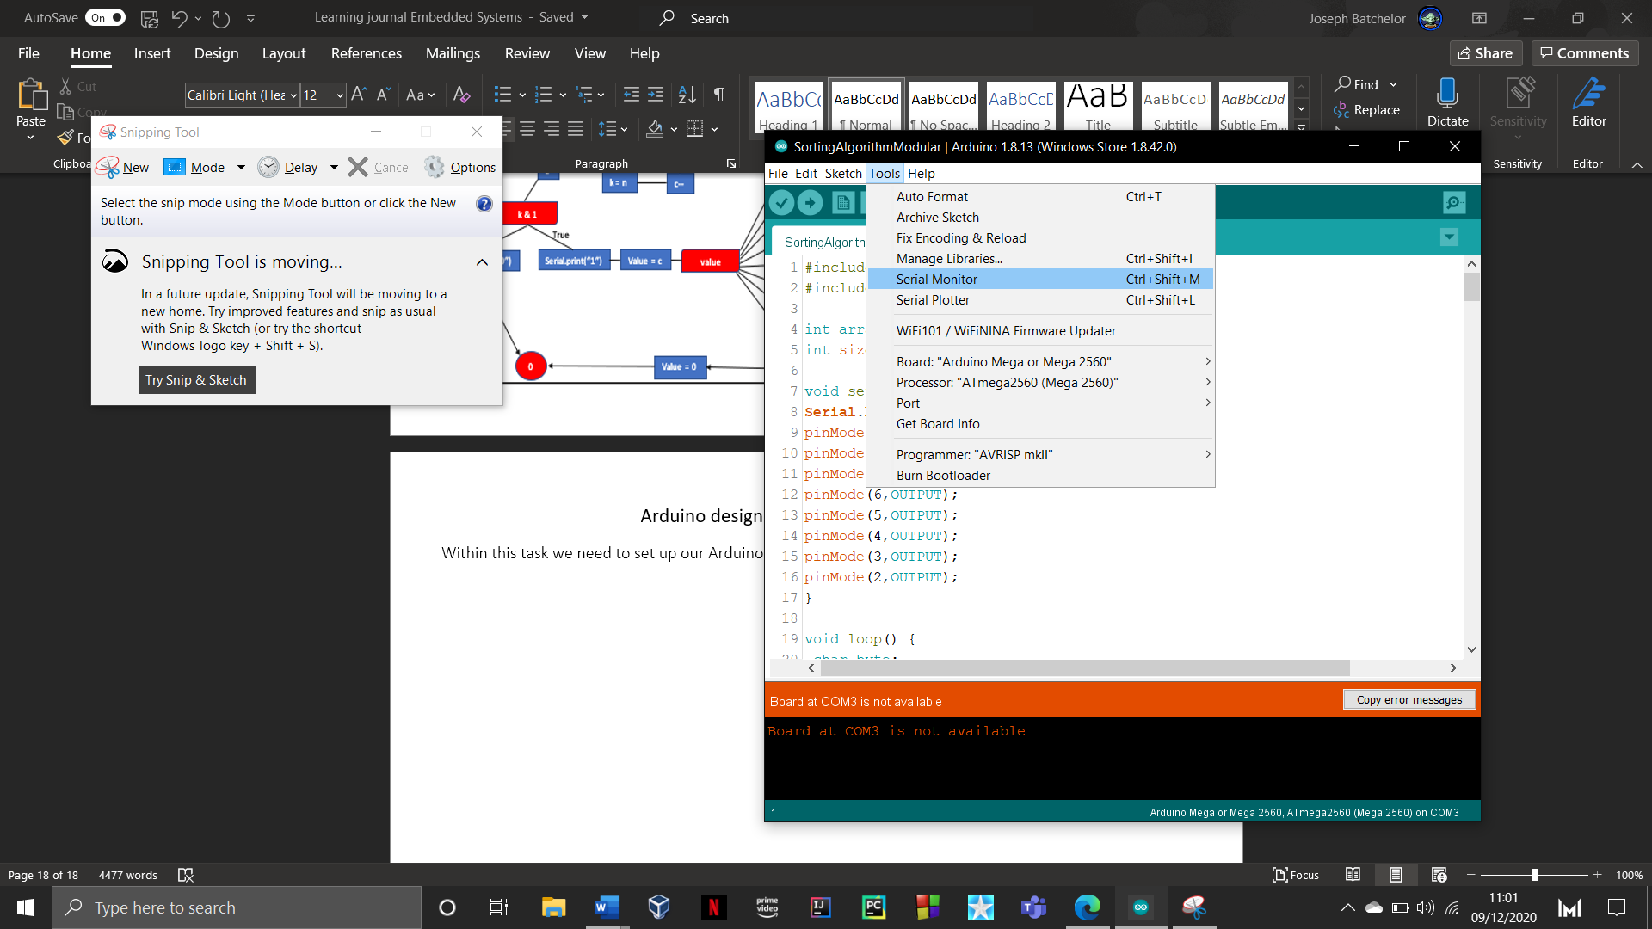

This task required the use of the serial monitor. This is an IDE feature which act as a terminal and bridge of communication between the computer and the Arduino. It allows for the transfer of data and information.

To set the serial monitor you need to navigate to the tools options and click on serial monitor. As you can see in the image to the right you can also use the command “Ctrl + Shift + M”. Once opened a new window will be displayed.

When setting up our Arduino within the first task notice how the serial monitor still uses Com 3. The Com3 port is used for communication which allows for us to display information.

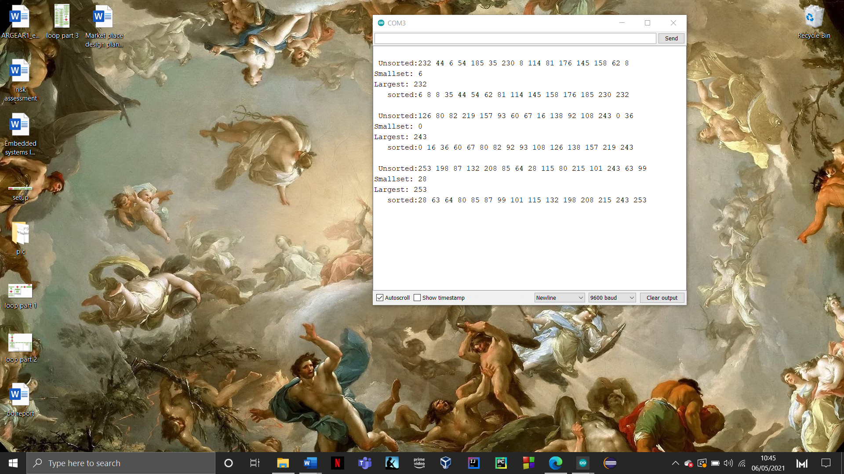Below is example of the information that is displayed when the Sorting code for task 2 is ran.

The next area of the serial monitor will display information.

This case task 2 will display both the unsorted array and sorted array, as well as the smallest and largest values in it.

The serial monitor can be broken down into three different areas.

The first area is the input, this will send data from your computer to the Arduino to be used for different feature.

With task if the users enters any value greater than or equalled to 0 this will start the sorting algorithm.

The final area allows you to change how you would like to display your information, as you can see, I’ve set mine on a newline which will display every print statement on a new line, this can be changed to other options by simply clicking on the drop down. The next drop-down option is used to set the speed at which you wish to transfer data at. The higher the number the faster it transfers at. It is important to know that some Arduinos have a set speed which in this case the mega 2560 has a max speed of 9600 baud (baud is the unit of transmission).The last option “clear output” will clear the terminal and remove all the printed content.

**Sorting algorithm**

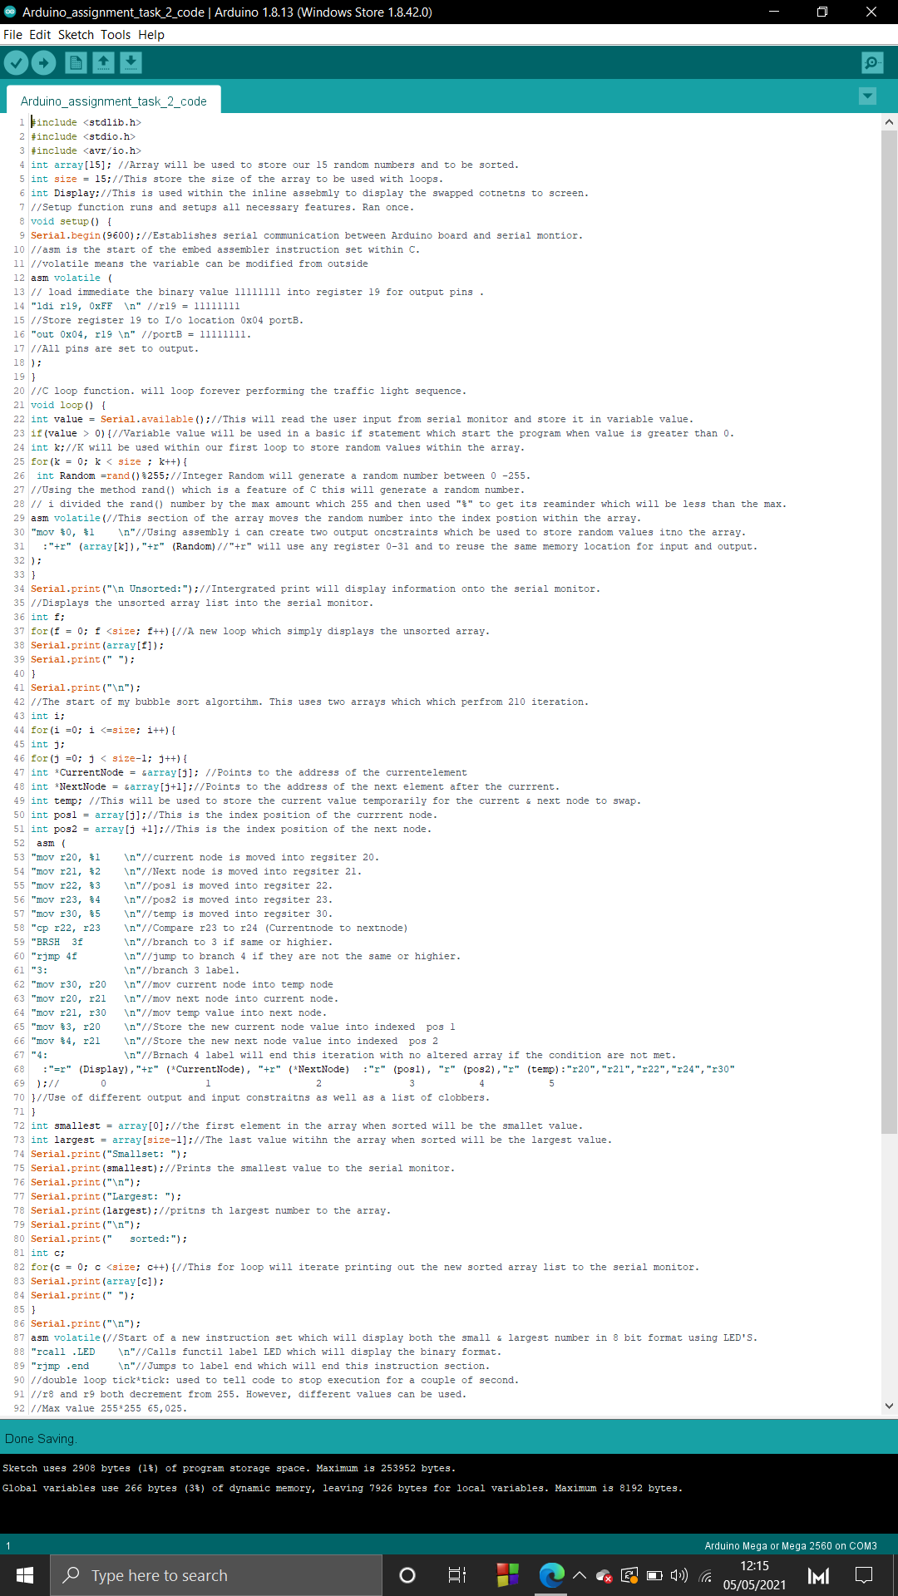This section of the report will break the down the sorting algorithm code**.**

****This first section of the sorting algorithm code is function setup. This function is designed to be ran once which will set up the Arduino environment. This function will set all pins being used to output with the use of bit manipulation within the inline assembly. By creating a register and storing the binary value 11111111 this this will tell the I/O location (0x04) to turn all pins from 0000000 to 11111111, which essentially means on. Additionally, I have created to global variables called **array** Which will hold the random values to be sorted**, Size** which keep the size of the arrayand  **Display** is used within a later instruction set as an output constraint. We also had to setup the serial monitor to be used for user interaction, this will be used to trigger the sorting algorithm.

This next section is of the sorting algorithm in the function loop. This function will hold majority of my code, this is because the sorting algorithm will constantly rearranged different arrays of different values.

The start of function loop is generating random values with the use of both C and assembly. Using a basic for loop this will hold my inline assembly which will use two constraints to move the randomly generate number into the index position. This will create my random unsorted array.

The next section of code is another basic for loop which is designed to iterate through the array and print the unsorted contents to the serial monitor. Using the Serial.Print() function this allows me to display text and value on screen to be seen.

This next area in function loop is the instruction set that performs the bubble sort algorithm. This is performed with two C for loops with one inner and one outer loop. This will allow for continuous update for the variables created. The inline instruction set uses 6 constraints which are the C variables created within the inner loop. These will be used to iterate through the array as well as to swap the values around. The assembly instruction set can be broken down into three areas.

The first area stores the C variables into registers by using their constraints. This allow me to manipulate the value without having to change the original value within the C variable. The next section compares the current index value and its neighbour to see if they are the same or greater than it.

The next and final section is the branch areas. There are two possible branches that can take place. The first one is when the values have been compared, if the current is greater than its neighbour it will branch to .3 and perform the bubble sort method which swap the values around between each other.

****Else if it is not greater than then it will jump to the next branch (.4) which performs nothing. This will do this for 210 times which is the combined number of iteration that both loops perform.

After the inline bubble sort algorithm has finished the next section simply prints the smallest and largest values within the array as well as new sorted array with the use of a basic C for loop.

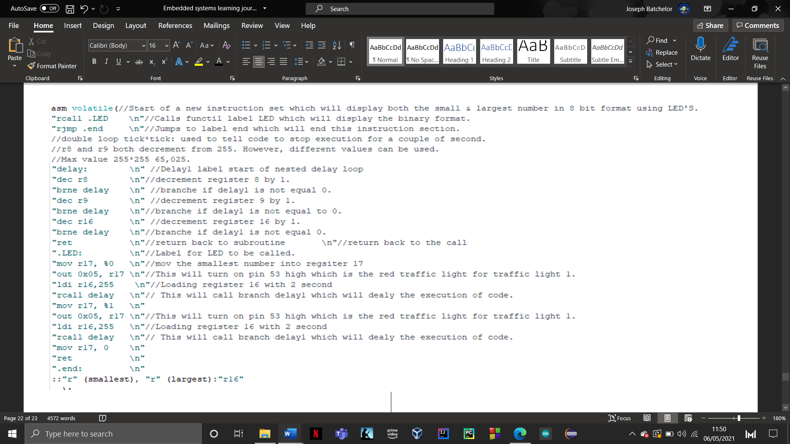This is the last section of function loop which is designed to illuminate the correct LEDs for the binary display of the biggest and smallest values. By using the two C variables smallest and largest these can be used as input constraints which will be stored int register 17 to alter the output of the LED’s.

Assessment overview

**Task 1:** Traffic light simulation Using Assembly language review

Creating the traffic simulation using assembly was an easy process it consisted of using basic mnemonics as well as persisting understanding from the last assessment of how to design and layout the code. Performing each of the tasks was straight forward as you simply add on top off each task. Designing the flowchart was a very tedious task to do as I have never designed one with the use of assembly. There unfortunately was not a lot of resources online on how to create one. This tasks flowchart became a messy display of everything fitted into a small area. Overall, I very much enjoyed this task and developing the code.

**Task 2:** Sorting algorithm using Assembly language review

This was an extremely hard task to do as finding resources online was very slim as not much regarding inline within the assembly environment. I based my design off a bubble sorting algorithm which worked as well as my already existing semester 1 assignment. Some improvements that I would like to add is the ability to not use C for loops and use Assembly loops however, I was unable to get this feature to work, which is why I resulted to using C. However, I have manged to create the main task of sorting the values using assembly which again was a hard task to do. Additionally, illuminating the correct binary LEDs was any easy task as it shared some ideas from the previous traffic light task. Overall, I found this task really hard and challenging and still enjoyable to do.